Coraline
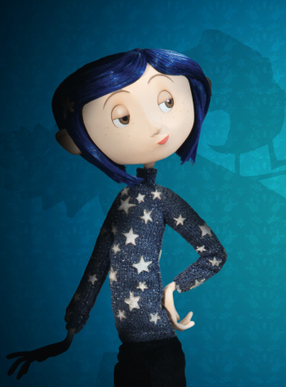
Task 1. Discuss in pairs:
- Do you like your parents?
- What do you want to change in them? Why?

Task 2. Choose correct answers:
- What was Coraline looking for?
a) a well b) a cat c) water
- Who owns the black cat?
a) Coraline b) Wybie c) nobody
- Who owns the Pink Palace?
a) Wybie’s grandma b) Coraline’s parents c) nobody
- What does the name “Wybie” mean?
a) Why were you bored? b) Why were you born? c) Why were you boring?
- Where did Wybie find the doll?
a) in the forest b) in his room c) in his grandma’s trunk
- What did Coraline’s father tell her to do?
a) explore the house b) do some gardening c) go playing in the rain
- What did Coraline find in the living room?
a) boxes b) snow globes c) a little door

Task 3. Answer the questions:
- Who did Coraline find behind the little door?
- What were they doing?
- What was the song about?
- Where does Bobinsky work?
- What was in parcels for Bobinsky?
- Who warned Coraline not to go through the little door?
- Who else did Coraline visit?
- What did they see in Coraline’s cup?

Task 4. Discuss in pairs:
- Why did Coraline like the other world?
- Was it a dream or it was real?

Task 5. Watch and write true or false:
- Wybie had been in the Pink Palace many times before.
- Wybie thought that the Pink Palace was dangerous.
- Wybie’s grandma disappeared in the Pink Palace.
- Coraline’s other farther was in his study.
- The garden looked like Coraline.
- Another Wybie couldn’t talk.
- Coraline thought that another Wybie was cheerful.
- Coraline’s real mother bought her new gloves.
- Coraline’s real mother went shopping.
- Coraline went through the little door in her dream.

Task 6. Choose the correct answers:
- What tiny thing did Coraline have to do to stay in the other world?
a) close the little door
b) choose the colour of the buttons
c) have buttons instead of her eyes
- How did Coraline feel when asked to stay in the other world?
a) happy b) scared c) upset
- Why did the cat kill the mouse?
a) the cat was hungry b) it was a rat c) the cat didn’t like circus mice
- Why was the other mother angry?
a) Coraline wanted home
b) Coraline didn’t want chocolate
c) Coraline didn’t like the dinner
- Where did the other mother throw Coraline through?
a) the wall b) the mirror c) the door

Task 7. Answer the questions:
- Who did Coraline see in the dark room?

- Why had the beldam taken their eyes?

- What did they (people from question 1’s answer) ask Coraline to do for them?

- Why does the beldam steal children?

- Is it good or bad to be perfect? Why?

- Would you like to live in the perfect world with perfect people? Why?

Task 3. Match the words to the definitions:
1 | a clever trick that is used to catch someone | beldam
2 | information that helps you understand something | escape
3 | to use a needle and thread to make or repair clothes | trap
4 | An old woman, sometimes ugly, mostly evil, who enjoys hurting children | vanish
5 | to disappear suddenly | clue
6 | to get away from a place or dangerous situation when someone is trying to catch you or stop you | wonder
7 | something that makes you feel surprise | sew

