ENG3U Poetry Poster Project

Part 1 – Poem Hunting
Read each of the following Robert Frost poems at http://msgroomsclassnoic.weebly.com/eng3u.html . Choose one poem from the list that YOU LIKE the best! It should inspire emotions in you and make you think of images/colours when you read it.
Remember, shorter poems are not always the easiest to understand!

- A Prayer in Spring
- Mending Wall
- After Apple-Picking
- In a Disused Graveyard
Part 2 – Poem Analysis – Create an annotated poem (hand in)
You need to read the poem and annotate it (make notes on it), trying to discover:
- The explicit / literal (SURFACE) meaning of the poem – what the words actually say
- The implicit meaning of the poem – the (DEEP) meaning hidden under and between the words
- Literary and Poetic devices – how has the poet constructed the poem? What devices do they use?
- The impact of the literary devices on how you experienced the poem (How the devices change how we experience the poem)

Part 3 – Poster Creation (hand in)
Create a poster that includes the following REQUIRED Information:

- The title and author of the poem
- A copy of the poem itself
- One or more pictures that illustrate the poem or part of the poem. This will be evaluated on how well the picture illustrates an element of the poem AND HELPS WITH UNDERSTANDING THE POEM.

The Poster and paper should be neat, free of grammar and spelling mistakes, demonstrate your best effort, and look professional / creative. Your response paper (Part 4 should be typed)

Part 4 – Poem Explanation (hand in)
Write a ½ page to 1 page, TYPED (12pt font Single Spaced), paper that contains three paragraphs:
- Paragraph 1 – Summarize what the poem is saying on a literal level (surface meaning)
- Paragraph 2 – Summarize what message/meaning the author is attempting to convey. Is he/she telling a story, trying to entertain with humor, expressing love or another emotion, or preaching that certain behaviors should be changed or encouraged?
- Paragraph 3 – Explain how the imagery in the poem is illustrated with the pictures on your poster (Don’t forget you can also talk about colour, negative space, and text size as well as symbolism).

Poem selection approval: ______________________________

Annotated poem approval/conference: ______________________________

All 3 parts due: ______________________________

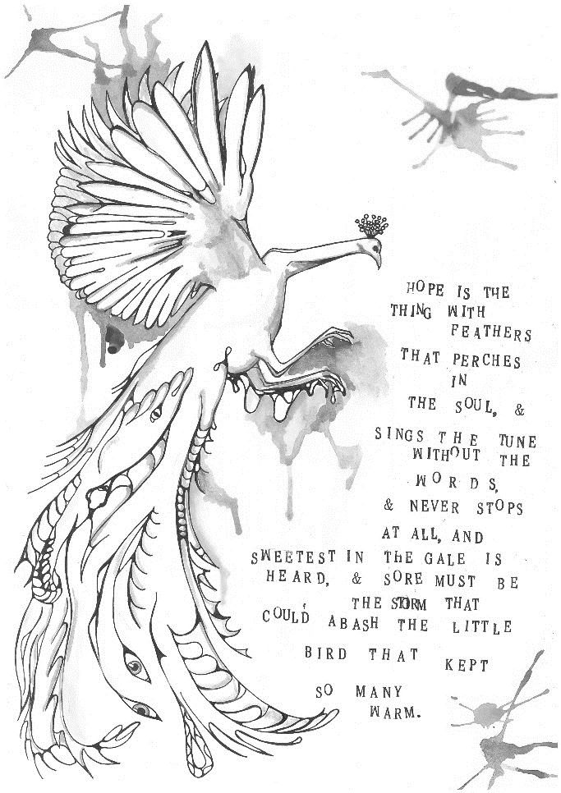
Examples of Illustrated Poems
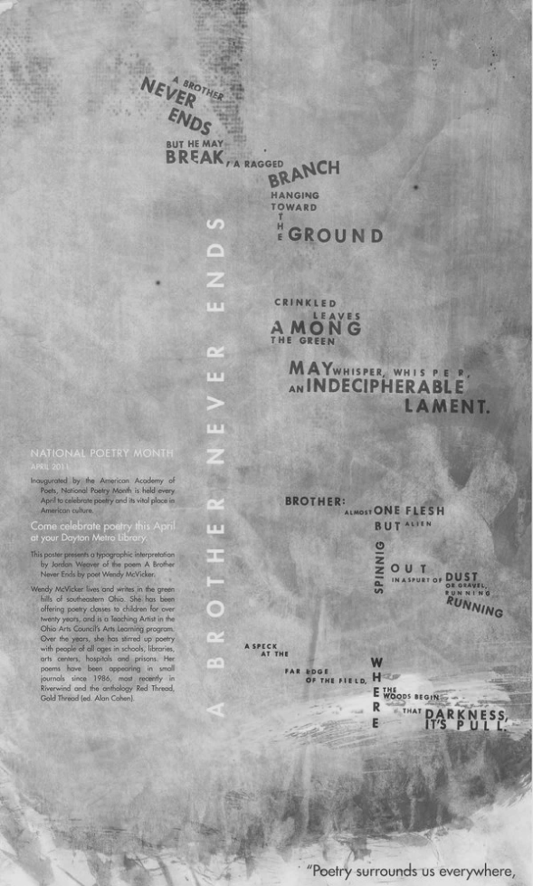
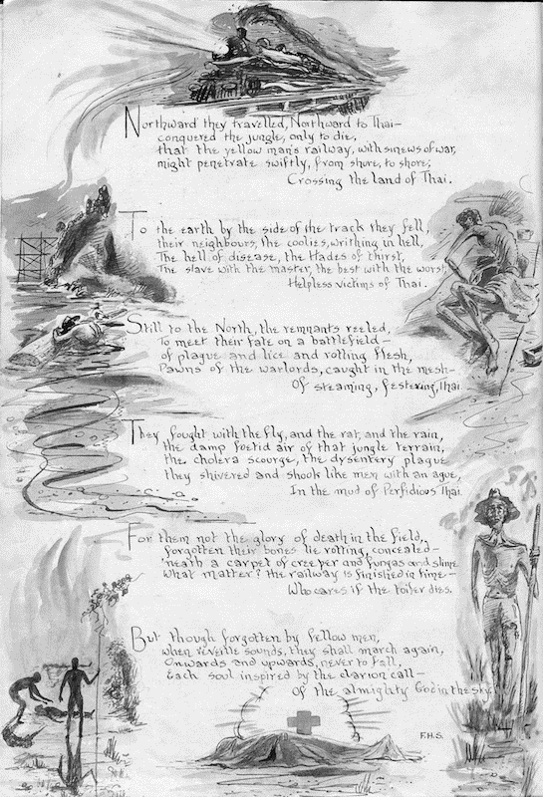
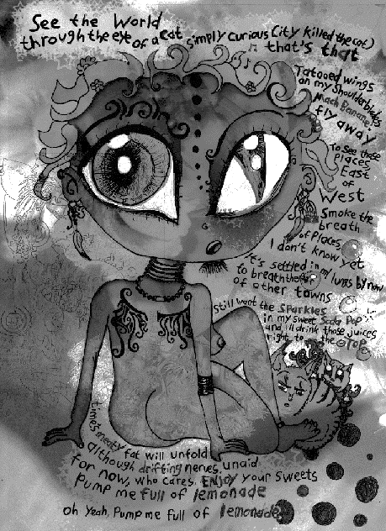

ENG3U Poetry Poster Project Rubric Poem: ____________________________ Name: ____________________________

Knowledge and  Understanding | Insufficient  6.0 8.0 | Level One  10.4 11 11.6 | Level Two  12.4 13 13.6 | Level Three  14.4 15 15.6 | Level Four  16.8 17.8 19 20 | K/U
▪ Demonstrates knowledge of poem, with an understanding of ideas, themes, and concepts | ▪ demonstrates insufficient knowledge of the poem, ideas, themes, and concepts | ▪ demonstrates limited  knowledge of the poem, ideas, themes, and concepts | ▪ demonstrates adequate  knowledge of the poem, ideas, themes, and concepts | ▪ demonstrates considerable  understanding of the poem, ideas, themes, and concepts | ▪ demonstrates thorough  understanding of the poem, ideas, themes, and concepts | ___  20
Thinking | 9.0 12 | 15.6 16.5 17.4 | 18.6 19 20.4 | 21.6 22.5 23.4 | 25.2 26.7 28.5 30 | T
▪ Uses critical and creative thinking processes to analyze themes and ideas in the poem  ▪ Explains, analyses, and  synthesizes ideas, themes, and concepts | ▪ little evidence of effective critical and creative thinking processes  ▪ insufficient explanation of ideas | ▪ uses critical and creative thinking processes with limited effectiveness  ▪ provides limited explanation of ideas | ▪ uses critical and creative thinking processes with some effectiveness  ▪ provides explanation and shows some analysis of ideas | ▪ uses critical and creative thinking processes with considerable effectiveness  ▪ shows considerable analysis and synthesis of ideas | ▪ uses critical and creative thinking processes to a high degree of effectiveness  ▪ shows thorough analysis and skillful synthesis of ideas | ____  30
Communication | 9.0 12 | 15.6 16.5 17.4 | 18.6 19 20.4 | 21.6 22.5 23.4 | 25.2 26.7 28.5 30 | C
▪ Organizes information and ideas with clarity and focus  ▪ Uses language and style  appropriate to purpose and audience (diction, voice, sentence structure, devices)  ▪ Communicates ideas through images | ▪ lacks clear sense of direction  ▪ demonstrates a lack of  competence in the use of  language and style  ▪ little communication of ideas | ▪ frequent loss of focus and logical sequencing of ideas  ▪ language and style are  frequently ineffective and demonstrate limited sense of audience and purpose  ▪ communicates ideas with limited effectiveness | ▪ occasional lapse(s) in focus and/or logical sequencing of ideas  ▪ language and style are  occasionally ineffective, but demonstrate some sense of audience and purpose  ▪ communicates ideas with some effectiveness | ▪ organization is clear, focused, and logical  ▪ language and style are effective and demonstrate a considerable sense of audience and purpose  ▪ communicates ideas with considerable effectiveness | ▪ organizes information and ideas with a high degree of coherence and unity  ▪ language and style are  sophisticated, well-crafted, and engaging with a strong sense of audience and purpose  ▪ communicates ideas with a high degree of effectiveness | ____  30
Application | 6.0 8.0 | 10.4 11 11.6 | 12.4 13 13.6 | 14.4 15 15.6 | 16.8 17.8 19 20 | A
▪ Makes connections within and between poem to poster  ▪ Includes complete annotated poem | ▪ makes little to no connections within and between poem to poster  ▪ annotated poem is not included | ▪ makes few connections within and between poem to poster  ▪ annotated poem is and included is somewhat complete | ▪ makes some connections within and between poem to poster  ▪ annotated poem is included and creative | ▪ makes considerable connections within and between poem to poster  ▪ annotated poem is included, creative, and important | ▪ makes considerable connections within and between poem to poster  ▪ annotated poem is included, creative, professional, and important | ____  20
Comments: |  |  |  |  |  | Total  ____  100

