Name: Date: ENG3U
ENG3U Persuasive Essay on a Short Story

In his essay, “Why We Crave Horror Movies,” Stephen King argues that horror movies allow people to release the darkest parts of their nature in a non-destructive way.

Your task is to examine how much King’s argument can be applied to short stories. In a 4 to 5-paragraph essay, you need to analyze one of the short stories studied in class, in terms of the points covered in King’s essay.

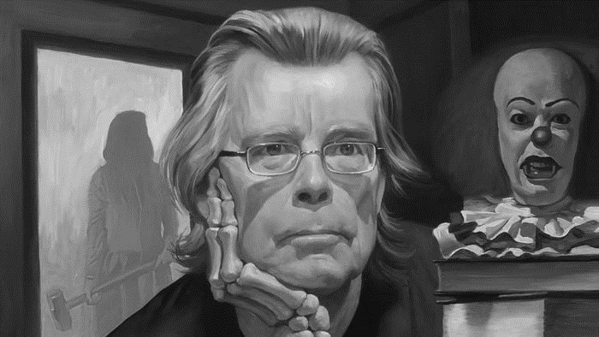
Some ideas to consider:
- How does the story reveal the “potential lyncher” in us all?
- What does the story reveal about human nature?
- In what way is the story a release for the reader’s uncivilized feelings?
- In what way is the story a release for the author’s uncivilized feelings?
- Does the story confirm the author’s and/or reader’s feelings of normality?
- How are the Freudian concepts of the id, ego, and superego related to the story and King’s arguments?

This is a formal literary essay, and not a plot summary. You should focus on a string thesis statement with good supporting points to prove your argument. Your discussion will be made better by frequent and direct references to both the story and King’s essay, as well as the handouts on Freud’s theory, to support any claims you make in your essay. Your essay should be written in a formal tone, without the use of contractions (like “don’t”), personal pronouns (“I”), or conversational language (except within quotations).

Your assignment should be:
- 600-800 words
- Typed and printed out
- Follow proper MLA structure (see handout)

Outline due: ____________________________

Rough draft due: ____________________________

Final good copy due: ____________________________
ENG3U Short Story Persuasive Essay Rubric Name: ____________________________

Knowledge and  Understanding | Insufficient  6.0 8.0 | Level One  10.4 11 11.6 | Level Two  12.4 13 13.6 | Level Three  14.4 15 15.6 | Level Four  16.8 17.8 19 20 | K/U
▪ Demonstrates knowledge of subject, facts, and text with an understanding of ideas, themes, and concepts | ▪ demonstrates insufficient knowledge of the subject, and ideas, themes, concepts | ▪ demonstrates limited  knowledge of the subject and ideas, themes, concepts | ▪ demonstrates adequate  knowledge of the subject and ideas, themes, concepts | ▪ demonstrates considerable  understanding of the subject and ideas, themes, concepts | ▪ demonstrates thorough  understanding of the subject and ideas, themes, concepts | ___  20
Thinking | 9.0 12 | 15.6 16.5 17.4 | 18.6 19 20.4 | 21.6 22.5 23.4 | 25.2 26.7 28.5 30 | T
▪ Formulates and refines a thesis that addresses the prompt  ▪ Integrates specific and compelling evidence to support thesis  ▪ Explains, analyses, and  synthesizes ideas, facts, themes, and concepts | ▪ thesis is inadequate and/or does not address the prompt  ▪ provides inadequate,  inaccurate, and/ or irrelevant supporting evidence  ▪ insufficient explanation of ideas and/or mere summary | ▪ formulates a limited thesis that refers to the prompt  ▪ provides limited supporting evidence which is frequently vague or inappropriate  ▪ provides limited explanation of ideas | ▪ formulates a developing thesis that addresses the prompt  ▪ provides some supporting evidence, but is occasionally vague or inappropriate  ▪ provides explanation and shows some analysis of ideas | ▪ formulates a reasonable thesis that meaningfully addresses the prompt  ▪ integrates considerable and convincing supporting evidence  ▪ shows considerable analysis and synthesis of ideas | ▪ refines a thesis that addresses the prompt with insight  ▪ integrates substantial and compelling supporting evidence  ▪ shows thorough analysis and skillful synthesis of ideas | ____  30
Communication | 9.0 12 | 15.6 16.5 17.4 | 18.6 19 20.4 | 21.6 22.5 23.4 | 25.2 26.7 28.5 30 | C
▪ Organizes information and ideas with clarity and focus  ▪ Uses language and style  appropriate to purpose and audience (diction, voice, sentence structure, devices)  ▪ Uses correct language structures of Standard Canadian English and its conventions of grammar,  usage, spelling, and punctuation | ▪ lacks clear sense of direction and/or has fewer than 600 words  ▪ demonstrates a lack of  competence in the use of  language and style and/or has fewer than 600 words  ▪ numerous major and minor errors interfere seriously with expression of ideas and/or has fewer than 600 words | ▪ frequent loss of focus and logical sequencing of ideas  ▪ language and style are  frequently ineffective and demonstrate limited sense of audience and purpose  ▪ errors frequently interfere with expression of ideas and/or frequently weaken impact of the essay | ▪ occasional lapse(s) in focus and/or logical sequencing of ideas  ▪ language and style are  occasionally ineffective, but demonstrate some sense of audience and purpose  ▪ errors occasionally interfere with expression of ideas and/or weaken impact of the essay | ▪ organization is clear, focused, and logical  ▪ language and style are effective and demonstrate a considerable sense of audience and purpose  ▪ errors do not significantly interfere with expression of ideas or weaken impact of the essay | ▪ organizes information and ideas with a high degree of coherence and unity  ▪ language and style are  sophisticated, well-crafted, and engaging with a strong sense of audience and purpose  ▪ few errors do not interfere with expression of ideas or weaken impact of the essay | ____  30
Application | 6.0 8.0 | 10.4 11 11.6 | 12.4 13 13.6 | 14.4 15 15.6 | 16.8 17.8 19 20 | A
▪ Transfers and applies knowledge of persuasive essay form and MLA style to the prompt | ▪ insufficient application of essay form and/or MLA style to the prompt, or  misunderstanding of the  prompt, results in an  ineffective essay | ▪ limited application of essay form and/or MLA style to the prompt results in an essay that is frequently ineffective | ▪ occasional lapse(s) in essay form and/or MLA style to the prompt results in an essay that is at times ineffective | ▪ consistent application of essay form and MLA style to the prompt results in an effective essay | ▪ a thorough command of the essay form, MLA style, and prompt results in a masterful essay | ____  20
Comments: |  |  |  |  |  | Total  ____  100

