ESLBO Movie Review Assignment

After watching the movie in class, your task is to write a movie review.
1) Give your movie a star-rating out of 5!
2) Your review needs to be separated into clear paragraphs, each covering the topics given below:

- Paragraph 1 – introduce the movie by the title and the year it came out; give the name of the director and the lead actors or voice actors; state whether you liked the movie or not; give an example of something really good and/or really bad in the movie

- Paragraph 2 – give a short summary of what happened in the movie, but don’t include any unexpected events or the ending

- Paragraph 3 – give your personal views on the social issues presented in the movie and what you learned from some of the characters’ approaches to these issues

Your review should be typed and spaced at 1.5 line spacing. It should be about 1-page long. Make sure you include all paragraphs in the order given, and proof read it for spelling and grammar mistakes.
Please include, in the top left-hand corner of the first page, your name, course code, assignment name, teacher’s name, and date.
Help save trees: Please remember to staple the assignment sheet and rubric to your movie review for grading!

- Review the Inside Out movie review example before you begin writing
- Use the checklist below to make sure you include all the important elements of a movie review. When proofreading your movie review, put a checkmark in each blank if you have included it!
Checklist: I have …

___ A star rating (out of five)
___ The title and year of movie
___ Name of director and lead actors/ voice actors
___ My opinion (I liked or disliked the movie)
___ An example of something good or bad about the movie
___ A summary of the main events
___ My personal views
___ What I learned from the movie
___ Organized my writing into 3 paragraphs
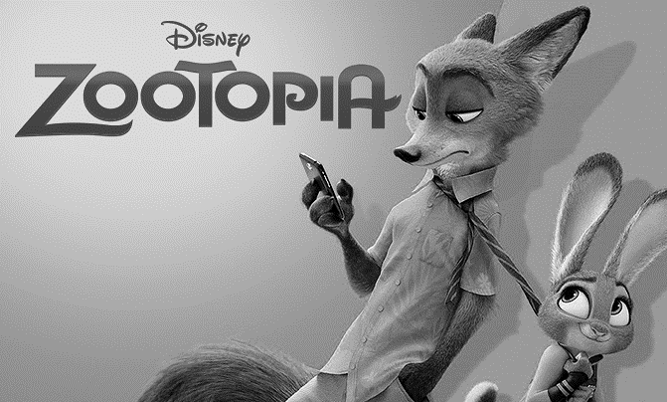

ESLBO Movie Review Movie: Indian Horse Date:_____________________ Name: _____________________________

Knowledge and  Understanding | Insufficient  6.0 8.0 | Level One  10.4 11 11.6 | Level Two  12.4 13 13.6 | Level Three  14.4 15 15.6 | Level Four  16.8 17.8 19 20 | K & U
- Conveys meaningful and relevant facts and details  - Includes all required information  - Demonstrates understanding of content | - Conveys insufficient meaningful and relevant facts and details  - Includes insufficient required information  - Demonstrates insufficient understanding of content | - Conveys limited meaningful and relevant facts and details  - Includes limited required information  - Demonstrates limited understanding of content | - Conveys adequate meaningful and relevant facts and details  - Includes adequate required information  - Demonstrates adequate understanding of content | - Conveys considerable meaningful and relevant facts and details  - Includes considerable required information  - Demonstrates considerable understanding of content | - Conveys considerable and important meaningful and relevant facts and details  - Includes all required information  - Demonstrates considerable and insightful understanding of content | ___  20
Thinking | 9.0 12 | 15.6 16.5 17.4 | 18.6 19 20.4 | 21.6 22.5 23.4 | 25.2 26.7 28.5 30 | T
- Uses planning skills – gathering information, organising, time use  - Uses processing skills – selecting, analysing, integrating, etc. | - Uses insufficient planning skills  - Uses insufficient processing skills | - Uses limited planning skills  - Uses limited processing skills. | - Uses adequate planning skills  - Uses adequate processing skills | - Uses considerable planning skills  - Uses considerable processing skills. | - Uses considerable and effective planning skills  - Uses considerable and important processing skills | ____  30
Communication | 9.0 12 | 15.6 16.5 17.4 | 18.6 19 20.4 | 21.6 22.5 23.4 | 25.2 26.7 28.5 30 | C
- Expresses and organises information  - Communicates to given audience  - Applies the proper use of language conventions (grammar, usage, spelling, and punctuation | - Expresses and organises insufficient information  - Demonstrates a lack of competence in communicating with audience  - numerous major and minor errors interfere seriously with expression of ideas | - Expresses and organises limited information  - Demonstrates limited competence in communicating with audience  - errors frequently interfere with expression of ideas and/or frequently weaken impact of the essay | - Expresses and organises adequate information  - Demonstrates adequate competence in communicating with audience  - errors occasionally interfere with expression of ideas and/or weaken impact of the essay | - Expresses and organises considerable information  - Demonstrates considerable competence in communicating with audience  - errors do not significantly interfere with expression of ideas or weaken impact of the essay | - Expresses and organises considerable and meaningful information  - Demonstrates considerable and sophisticated competence in communicating with audience  - few errors do not interfere with expression of ideas or weaken impact of the essay | ____  30
Application | 6.0 8.0 | 10.4 11 11.6 | 12.4 13 13.6 | 14.4 15 15.6 | 16.8 17.8 19 20 | A
- Presentation of information coherent and structured | - Presentation of information has insufficient coherence and structured | - Presentation of information has limited coherence and structured | - Presentation of information is adequately coherent and structured | - Presentation of information is considerably coherent and well-structured | - Presentation of information is considerably and meaningfully coherent and well-structured | ____  20
Comments: |  |  |  |  |  | Total  ____  100

