Gentle Warrior Lyrics
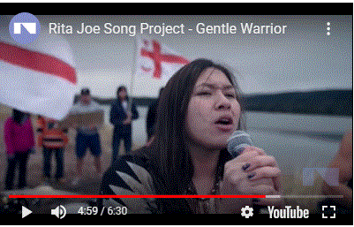

by Carter Chiasson, Ron Martin, Angelo Spinazzola, Devon Paul, Students of Allison Bernard Memorial High School https://nac-cna.ca/en/ritajoesong/gentle-warrior
Seen and heard by the Gentle Warrior’s word
Taught to forgive but NOT forget
Your Words are weak, my voice is strong
It carries in the wind, it carries in a song
CHORUS
I’m trying to speak but I can’t find my words
They snatched it away, shattered my world
Don’t say that I can’t, or pretend that I’m yours
Free me so my spirit can soar, as a warrior I’m stronger
Walk the path, follow the star
Feed the soul with tales of old
In the shadows we dance, in the dark we lie
With the river we flow with the earth we cry
CHORUS
I’m trying to speak but I can’t find my words
They snatched it away, shattered my world
Don’t say that I can’t, or pretend that I’m yours
Free me so my spirit can soar, as a warrior I’m stronger
Meet beyond the distant shore
Where lies and myths are no more
Two ways we talk, both ways we say
Words are the wings, carry us away
CHORUS
I’m trying to speak but I can’t find my words
You snatched it away, scrambled my world
I lost my talk, my courage, my pride
For 500 years it’s been hiding inside
No more hurt, no more sorrow, no more fear, no more shame
A Mesi Klusi, I’m going insane
Give me truth, give me knowledge, give me honor, no more blame
Give me hope, give me freedom, give me love, no more pain
CHORUS
I’m trying to speak but I can’t find my words
You snatched it away, scrambled my world
I lost my talk, my courage, my pride
For 500 years it’s been hiding inside
No more hurt, no more sorrow, no more fear, no more shame
A Mesi Klusi, I’m going insane
E’nikaq nsitunaq
Niskum, my Great Brave
Guide me so my spirit can soar
I’m a gentle warrior

