Identifying a Thesis in a Film
- Watch the video Blind by Yukihiro Shoda (https://www.youtube.com/watch?v=E2SgonaD4U0 )  - Work with a partner to brainstorm a thesis. Use the sentence pattern described above.  - Think about reasons, evidence and details.  - Make notes.  - Individually, fill out a graphic organizer with the thesis and supporting reasons/evidence.  - RESPOND to the video. Write a paragraph which describes your answer to the question Do you agree with the thesis in the video? Why/Why Not? | 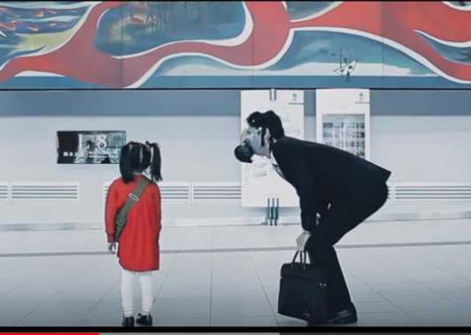
Film NOTES:

Graphic Organizer for Essay Paragraph 1: Introduction
Thesis Statement (everything in this box)
Main Idea /Argument: ________________________________________________________________________________________________________________________________________________________________________________________
Supporting Statement(reasons):
A)______________________________________________________________________________________________________________________________________________________________________________________
B)______________________________________________________________________________________________________________________________________________________________________________________
C)______________________________________________________________________________________________________________________________________________________________________________________
Concluding sentence: This (replace with thesis argument)_______________________________________________ _________________________________________________________________________________________________ can be seen/proven in the following paragraphs below.
RESPONSE:
Do you agree with the thesis in the video? Why/Why Not? (1-2 paragraphs maximum)

