Inside Out
Pixar's all-star tour of a preteen girl's head is a flat-out masterpiece
Peter Travers
June 17, 2015

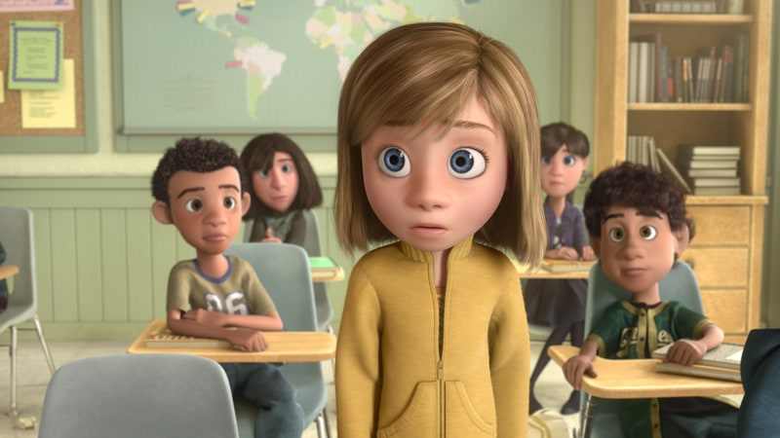
An 11-year-old girl wrestles with the bickering emotions inside her head. It sounds like a therapy session. Instead, Pixar's 15th feature is another landmark, an unmissable film triumph that raises the bar on what animation can do and proves that live action doesn't have dibs on cinematic art. Oh, did I say it was funny? It is, uproariously so, when you're not brushing away a tear.
Riley (voiced by Kaitlyn Dias) is upset that her dad (Kyle MacLachlan) and mom (Diane Lane) have moved her to San Francisco (colored in dull browns) from bright, snowy Minnesota, where she loved playing hockey with her BFFs.
It's a scary new school and no friends, except for her emotions: Joy (Amy Poehler, perfection) used to be in charge. Now she's on a trip with Sadness (Phyllis Smith, all touching gravity) to recover Riley's best memories. That leaves Fear (a comically hyper Bill Hader), Disgust (Mindy Kaling, mistress of dismissive cool) and Anger (Lewis Black finding the vocal equivalent of a head bursting into flames) in charge over at Riley HQ. Ah, adolescence explained at last.
The idea has been tried — remember TV's Herman's Head? — but never with the artful brilliance of filmmaker Pete Docter (Up; Monsters, Inc.). Docter gets into our control centers as well as Riley's. We all hear voices in our heads — no, not the kind that get you locked up. As envisioned by Docter, co-director Ronnie Del Carmen and co-writers Meg LeFauve and Josh Cooley, Inside Out isn't so much a tale of emotions at war as it is emotions angling for a truce, reflected in Michael Giacchino's glorious, mood-leaping score.
Too sophisticated? Maybe so when the film takes us to the dark subconscious, "where troublemakers go." Kids will probably roll with the abstract punches thrown by this burst of pure imagination. Parents and adults will likely be traumatized. You've been warned.

