Study Guide
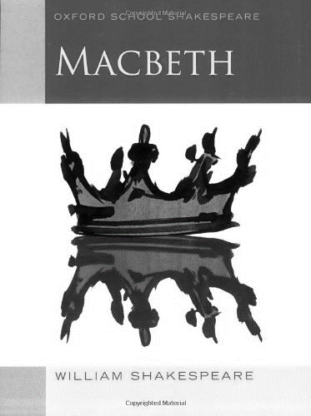
*Be sure to answer all questions in detail as these booklets will become your study notes*
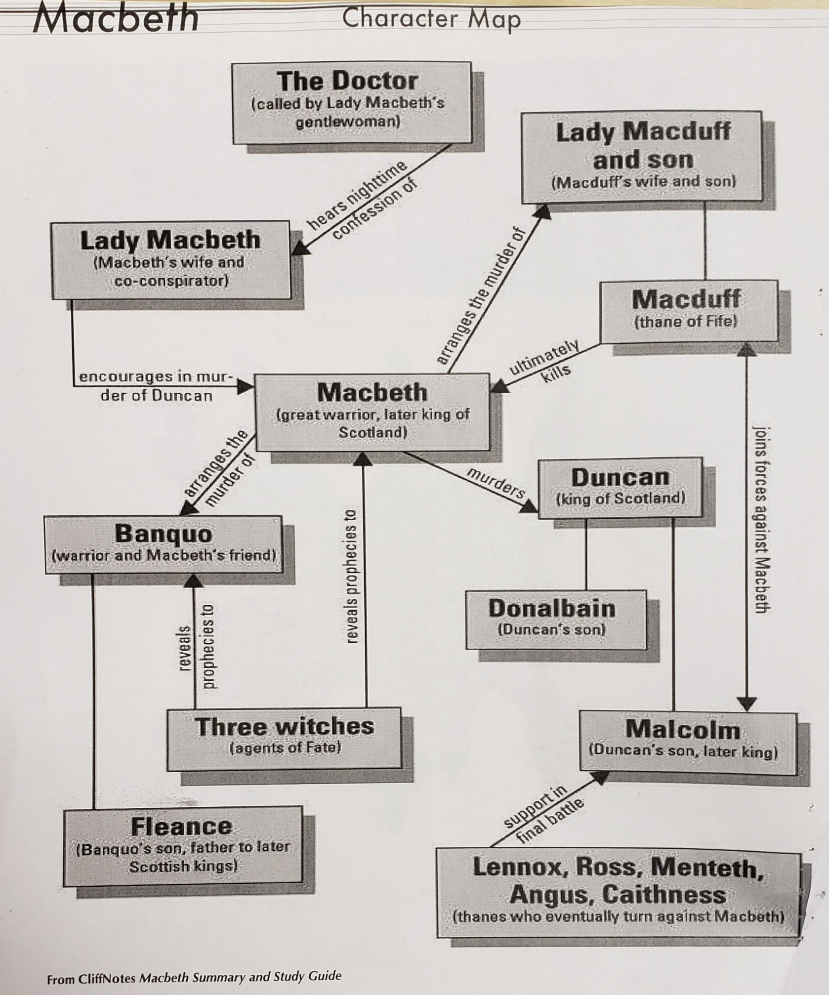

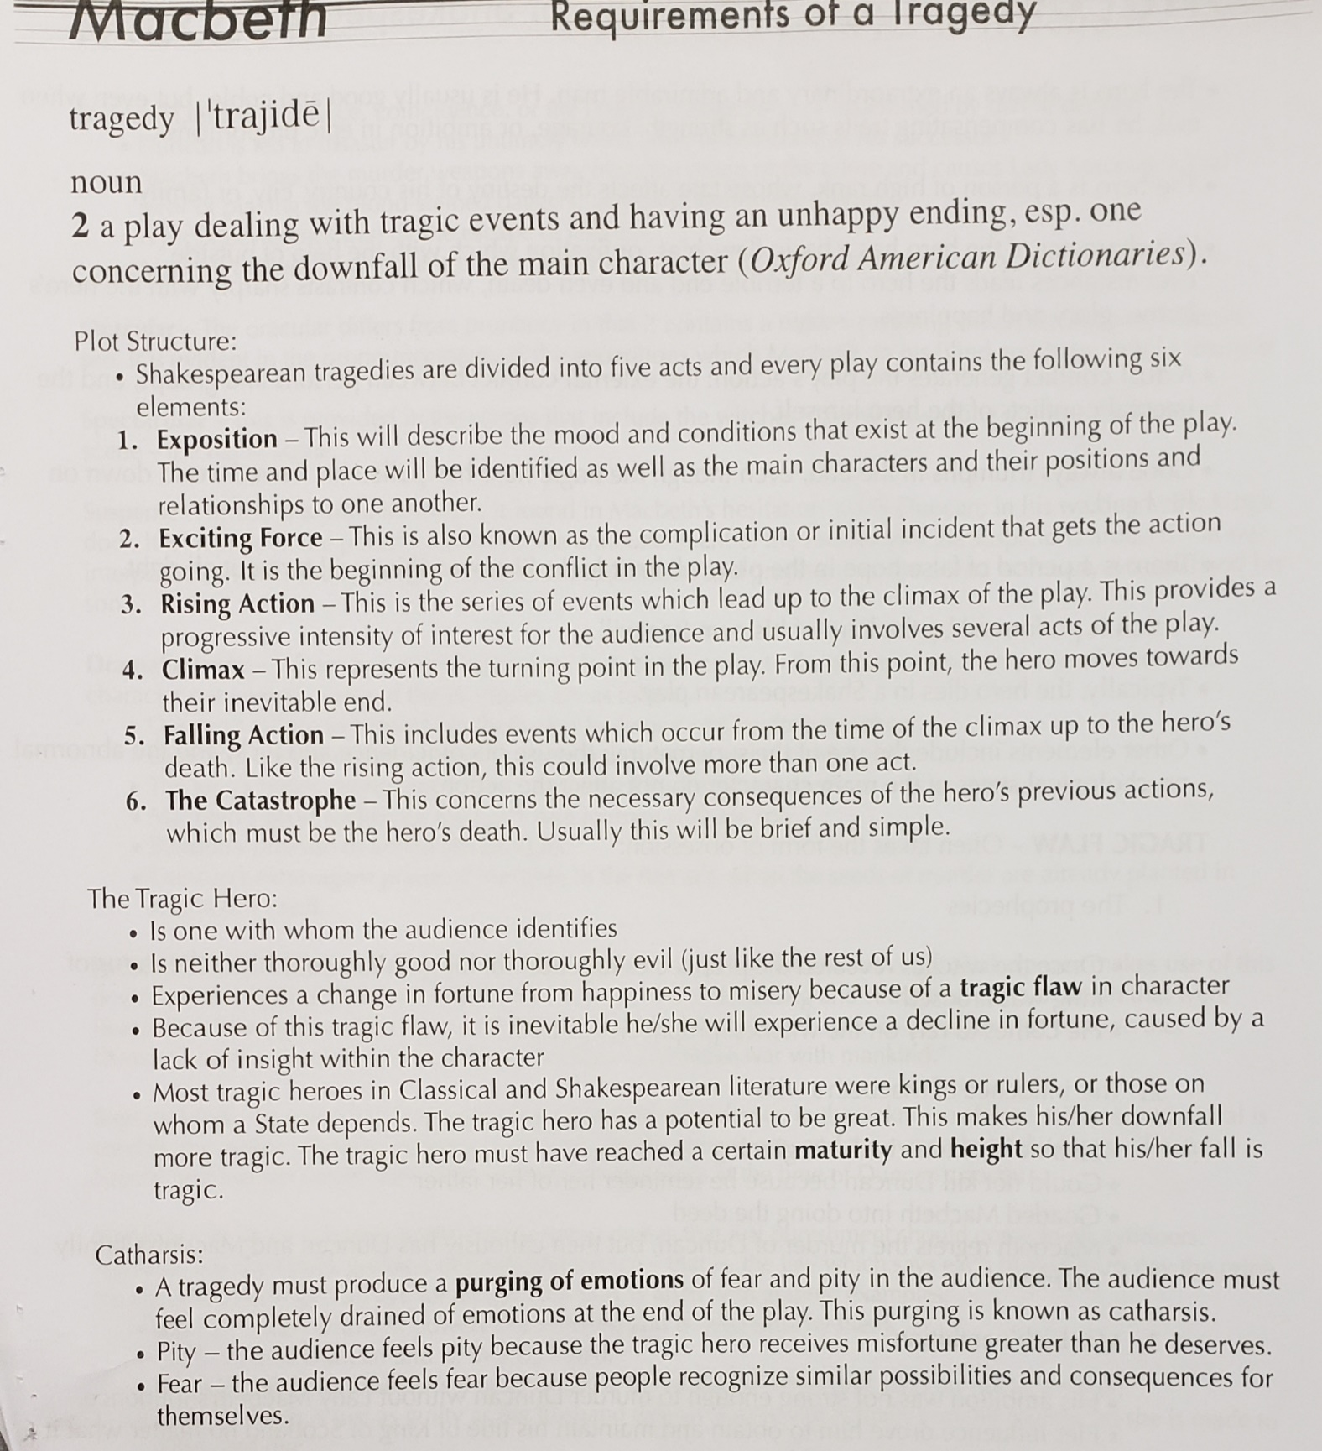

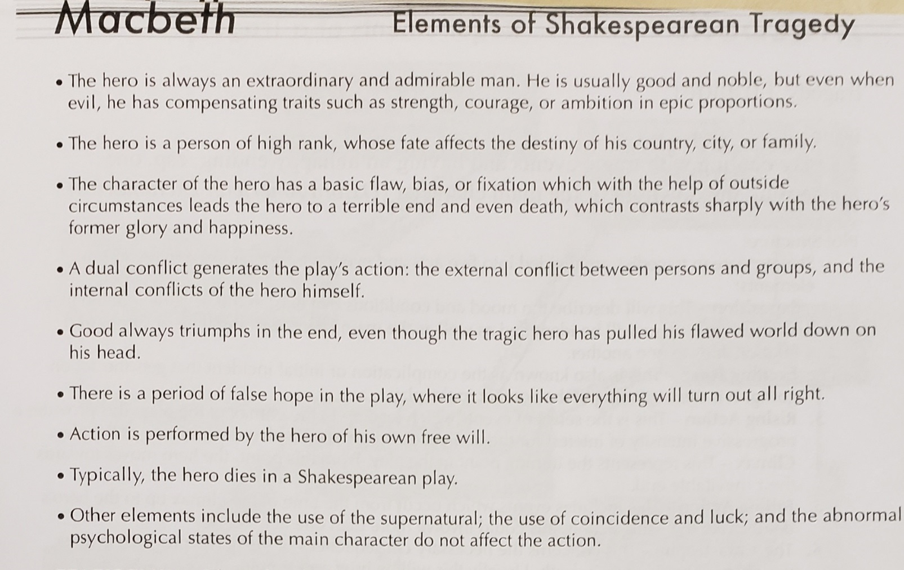
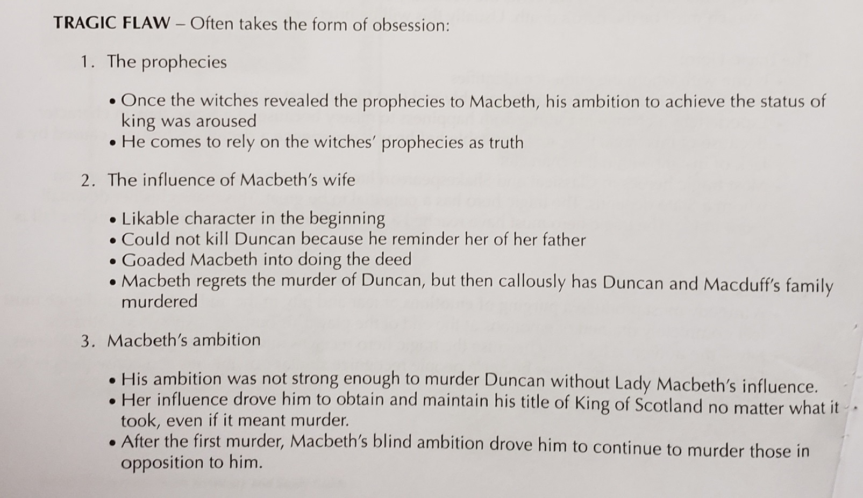
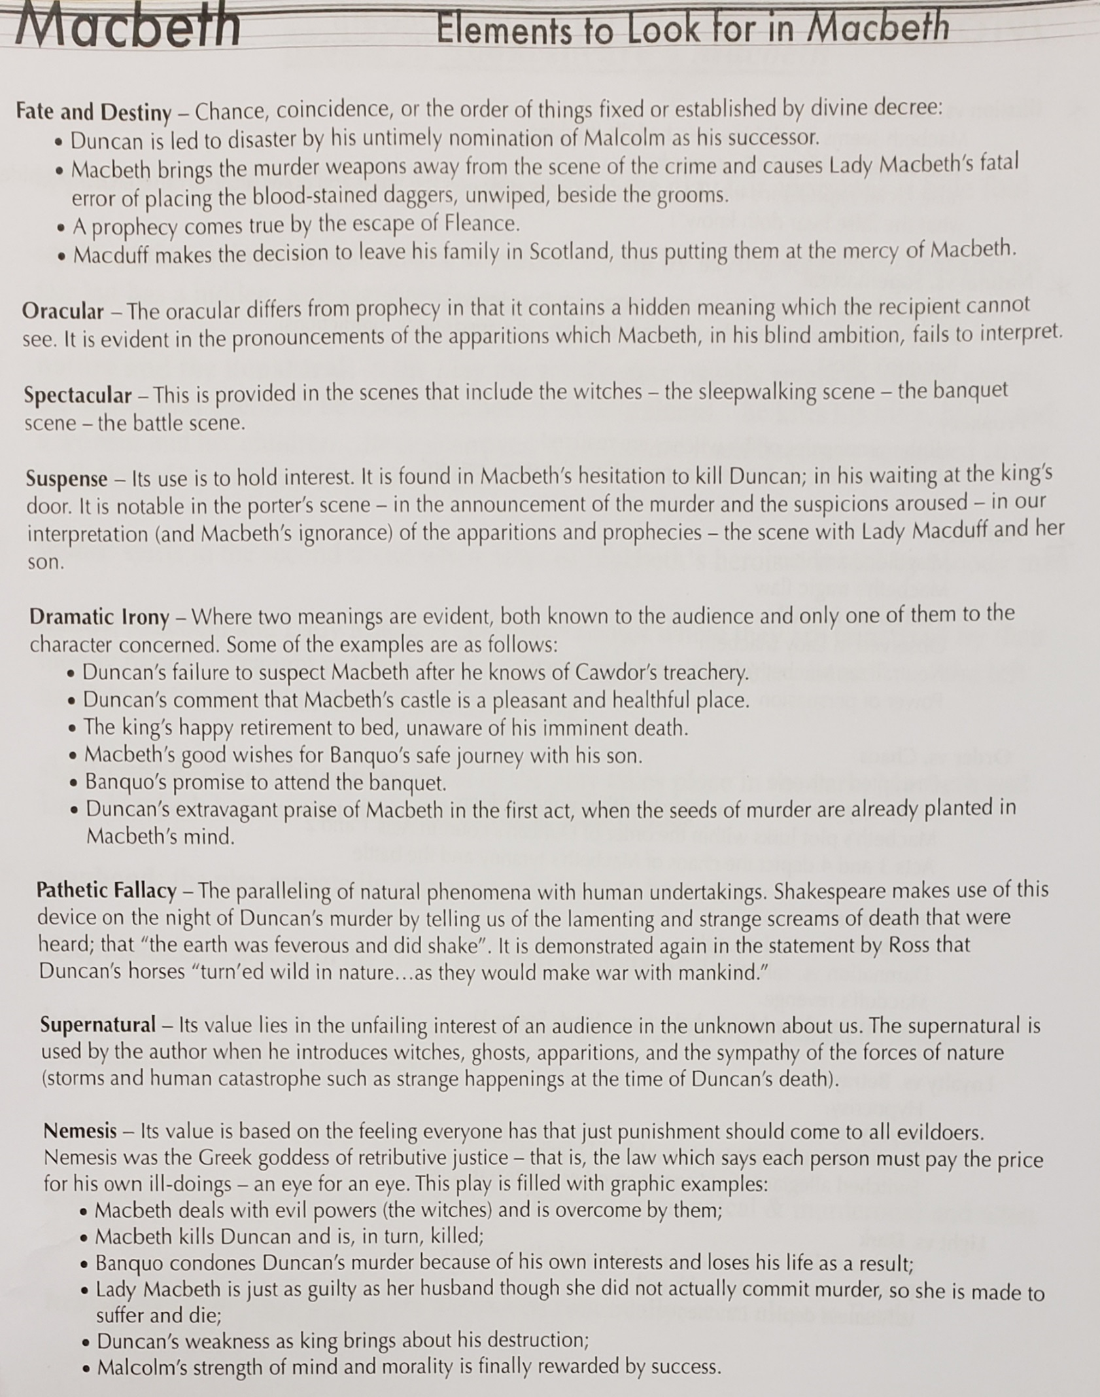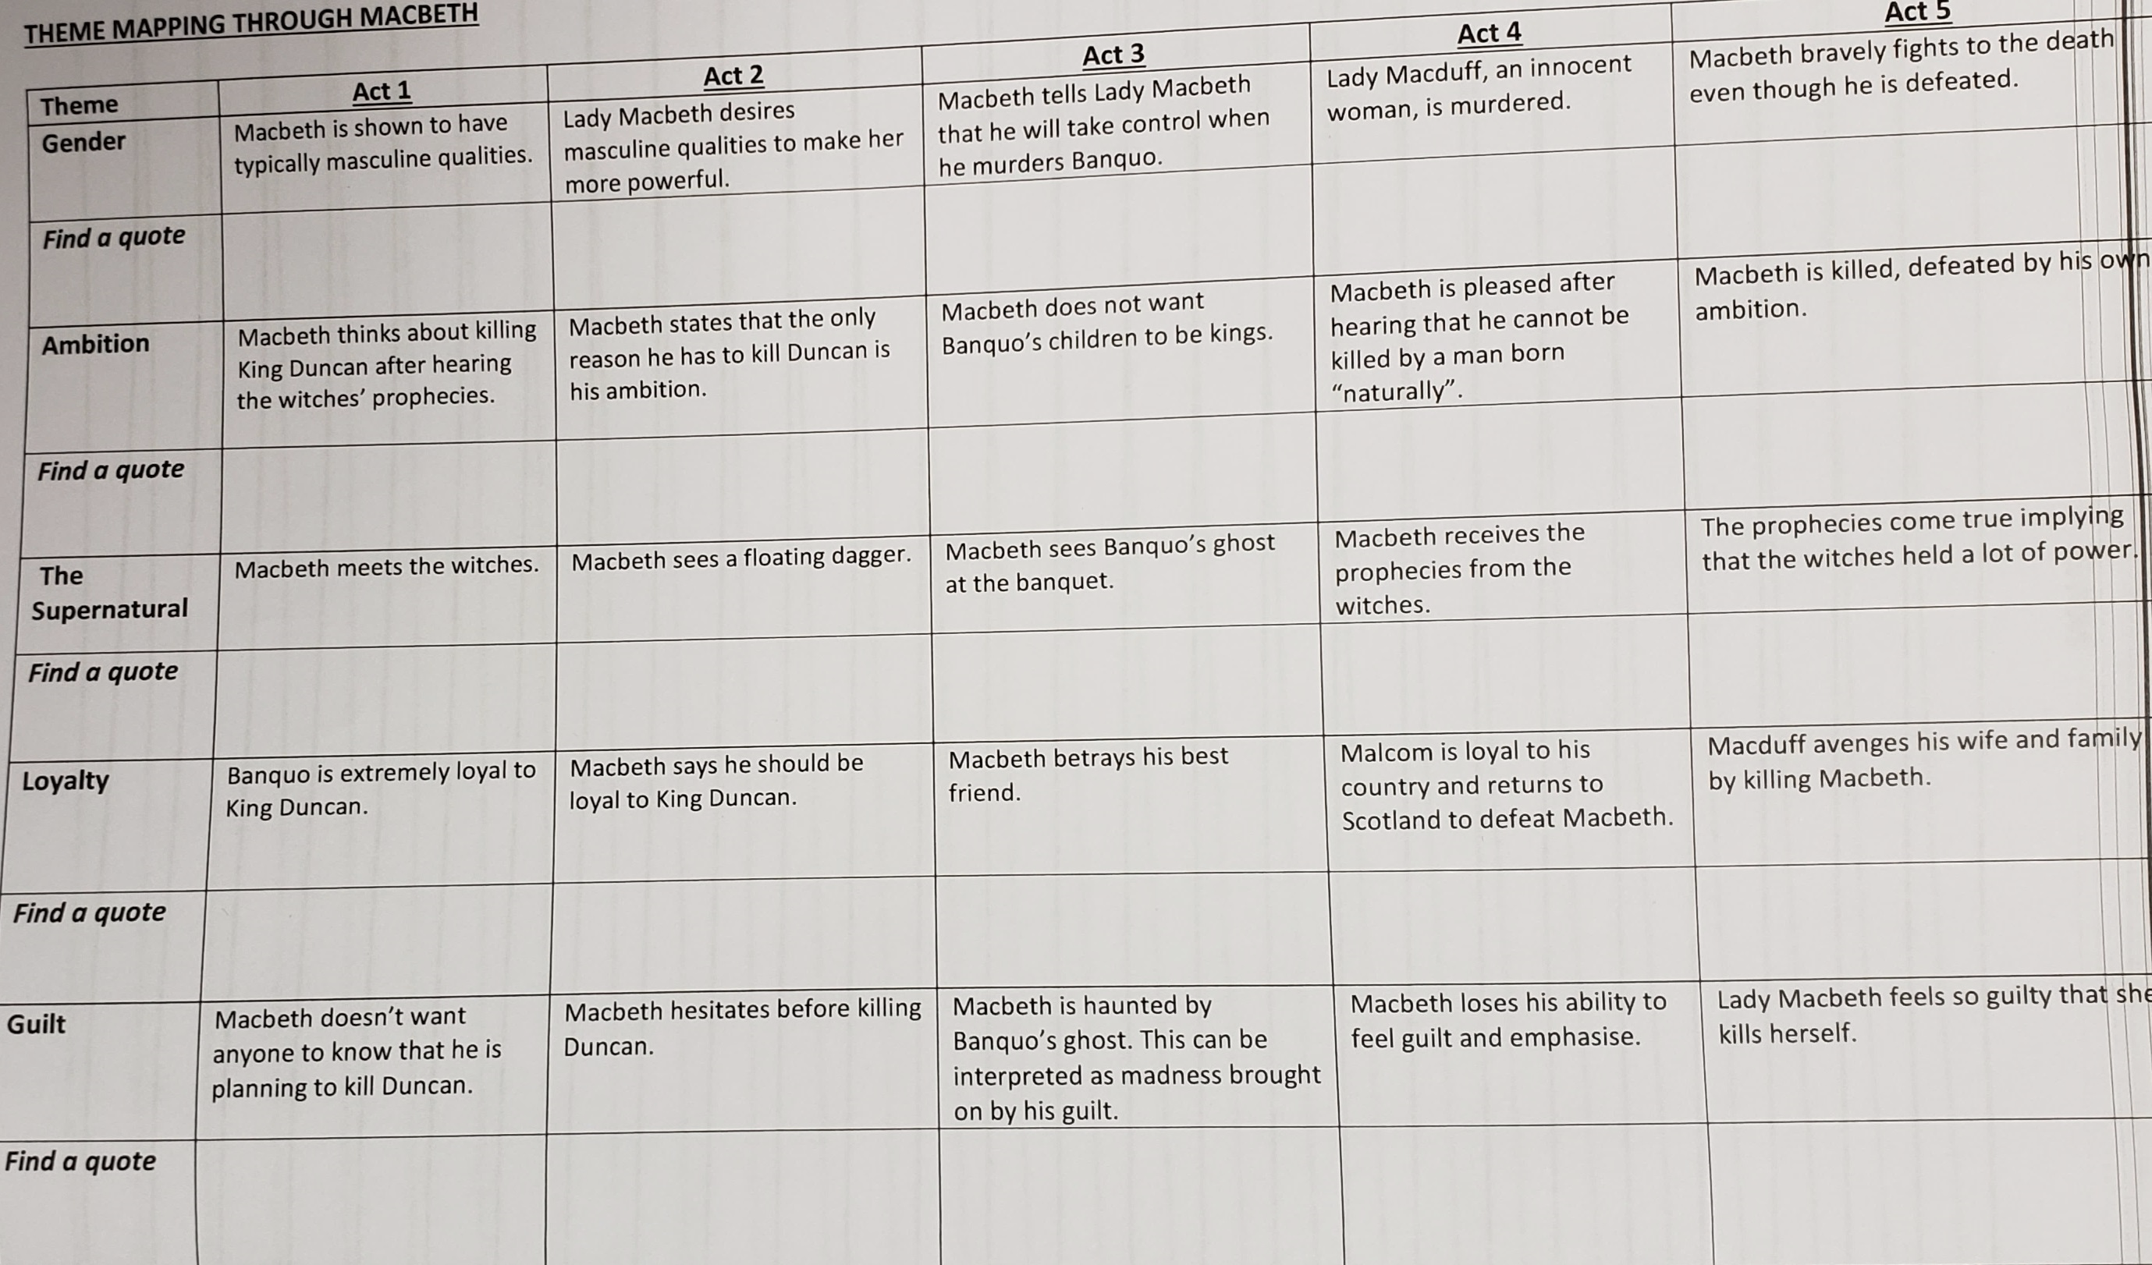
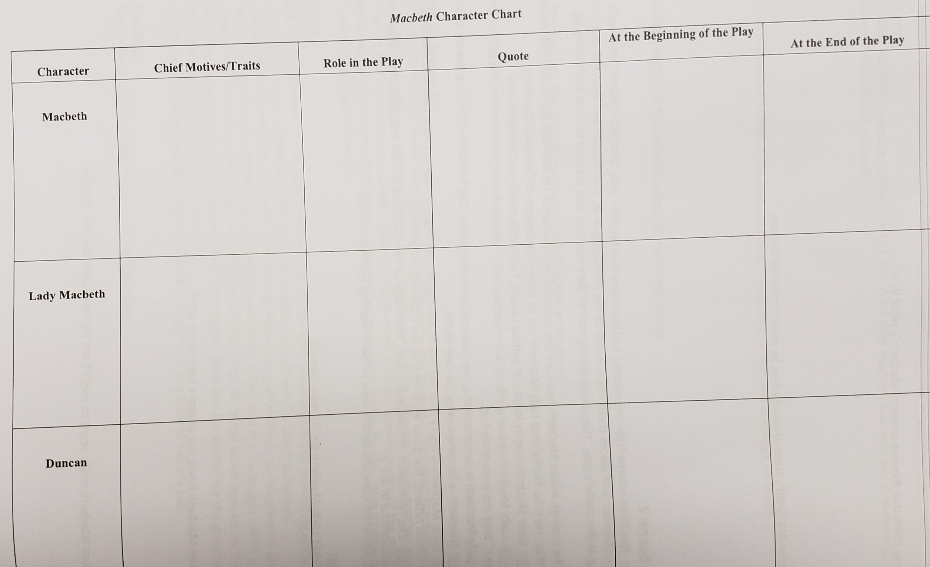
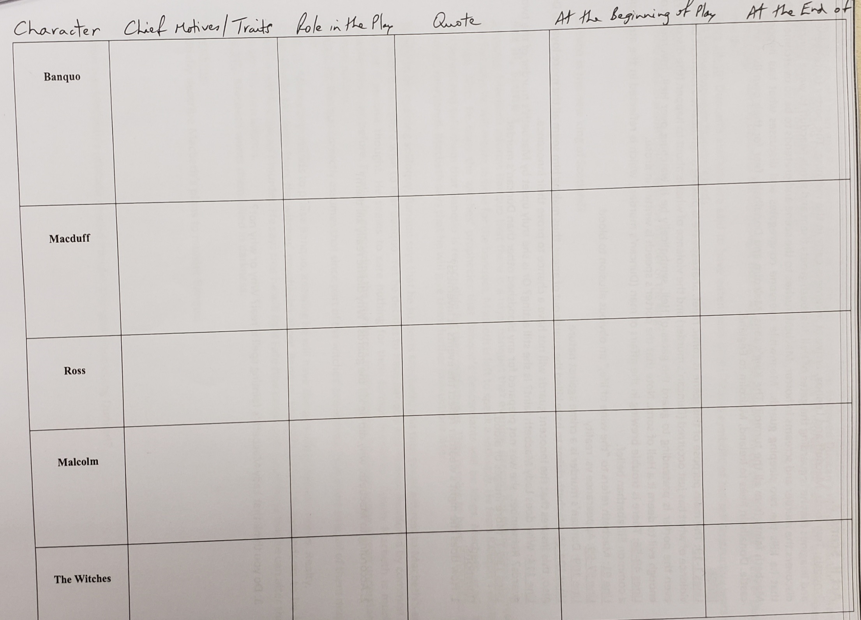
Study Guide for Macbeth
Adapted from student teacher Alan Newton

Act I, Scene 1.
Synopsis: Three witches meet in a field and discuss plans for a future meeting with Macbeth.

Notes: This opening scene is full of mystery and the supernatural. This sets the mood for the events to come. Also, the witches are very ugly and hideous in appearance. Much of the action to come could be described as ugly and hideous.
Line 12: “Fair is foul, and foul is fair.” Things aren’t what they seem to be. This introduces the important theme of appearance vs. reality.

Questions:
1. What type of mood or atmosphere is set by this scene?

Act I, Scene 2.
Synopsis: A messenger tells the King (Duncan) and his two sons (Malcolm and Donalbain) that Macbeth has defeated and killed the rebel Macdonwald through fierce fighting. Macbeth has also driven back the king of Norway and has captured the rebellious Thane of Cawdor (a member of the Scottish nobility). Duncan orders the Thane of Cawdor to be put to death and that Macbeth be given his title.

Notes: Though we are not given much background information, it is clear that Scotland has weak leadership. It has enemies from within and from outside. In fact, Scotland seems only to have been saved by the heroic efforts of one man, Macbeth.
Line 18: The image of blood is introduced. This image, which underscores the immense violence and bloodshed in this play, recurs throughout the play.

Questions:
1. Describe the conditions that exist in Scotland

2. Do you feel that Duncan is a strong king? Does he seem to be a good man? Explain your answers.

3. How is Macbeth characterized in this scene?

Act 1, Scene 3.
Synopsis: The three witches are reintroduced and they are talking about their evil powers (they plot to destroy an innocent sailor). Macbeth and Banquo, two Scottish lords, are returning from battle when they are met by the witches who have been waiting for them. The witches greet Macbeth with three titles: Thane of Glamis (which he is); Thane of Cawdor (which he is but he doesn’t know it); and King (which he will be). Macbeth is amazed. Banquo asks the witches if they are real or imaginary. The witches then tell Banquo that his future descendants will be kings, and then vanish. Two nobles approach and give Macbeth the King’s congratulations. They tell Macbeth that he is the new Thane of Cawdor. At this point, Macbeth and Banquo realize that one of the witches’ predictions has come true. Macbeth speaks his first soliloquy, which shows that he is torn in his feelings. He wants to be king, but realizes that he is contemplating murder. Then he realizes that he doesn’t have to act: Fate will make him king without his doing anything. Finally, all head for Duncan’s castle.

Notes: The witches again. Their foulness is in contrast with Macbeth’s glorious and honorable victories. Once the witches have spoken, Banquo notices that Macbeth is entranced by their words.
Line 30: The witches are called the “weird sisters.” Here, “weird” means able to tell the future.
Lines 51-2: Banquo asks if the witches are real or imaginary. Here again is the idea of reality vs. appearance.
Line 79-80: Appearance vs. reality.
Line 106-7: Macbeth refers to his new title as “borrowed robes.” This image of putting on clothes recurs throughout the play.
Line 116: Macbeth says that his greatest honor (the kingship) is yet to come. This shows his overpowering ambition. Lines 119-124: Banquo correctly warns that evil forces often tempt people with promised glory in order to lead them to destruction.
Lines 129-141: Macbeth is confused about whether the idea of his becoming king is merely a suggestion or an established fact. In other words, was the witches’ prediction reality or appearance? At this point, thoughts of murder bother Macbeth to the point that he can’t distinguish between what is real or not real. This will change soon.
Line 145: The image of putting on new clothes.

Questions:
1. What are the witches’ prophecies for Macbeth? For Banquo?

2. Who is more interested in the witches’ prophecies, Macbeth or Banquo?

3. What mixture of feeling does Macbeth show in lines 129-141?

Act I, Scene 4.
Synopsis: Duncan receives the report of the Thane of Cawdor’s death (who died very honourably). Macbeth and other lords enter and exchange compliments with the King. Duncan then announces that his oldest son, Malcolm, will be the next king. After hearing this, Macbeth realizes that Fate alone will not crown him: he must act. He now knows full well his intention to murder Duncan. Finally, all agree to spend the night at Macbeth’s castle (Inverness).

Notes: The most important event in this scene is when Duncan announces that Malcolm will be the next king. At this time, Scottish kings were not necessarily chosen through heredity. Thus, up until this time, Macbeth believed that he would be chosen by Duncan as the next king, which would mean that Macbeth could do nothing and still fulfill his ambition. Now he realizes that he can no longer be passive but must be active if he is to receive the crown. Only now can he admit to himself that he has thoughts of murder. These thoughts have probably been with him since the beginning, but have remained unconscious.
Lines 1-11: Cawdor, who was a traitor, becomes valiant at death. He is in contrast with Macbeth, who was once valiant but now is becoming a traitor.
Lines 12-14: Duncan’s statement is meant to apply only to Cawdor. Ironically, it also applies to Macbeth. Again we see the theme of appearance vs. reality.
Lines 50-53: Macbeth is obsessed with darkness. Remember that darkness is always a sign of evil thoughts or actions.

Questions:
1. In lines 12-14, Duncan is talking about the Thane of Cawdor. Why might his words apply equally to Macbeth?

2. What happens to make Macbeth realize that he himself must act (and not leave matters to Fate) if he is to become king?

Act I, Scene 5.
Synopsis: Lady Macbeth is at Inverness reading a letter from her husband. In it, he describes his encounter with the witches and also relates his desire for the throne. He reminds her that the prophecies affect her also: she will become queen. Lady Macbeth worries that her husband lacks the evil nature to kill Duncan. She plans to fill him with the courage to murder. After learning that Duncan will be staying the night at Inverness, Lady Macbeth invokes the evil spirits to remove all pity and feminine compassion from her soul so that she can follow through with her plans. When Macbeth arrives, she proposes her plans and tells him to let her arrange everything.

Notes: Lady Macbeth immediately shows herself to be evil. The idea of murdering Duncan is in her thoughts from the beginning. Unlike her husband, she has no second thoughts. Like her husband, she has much ambition for greater things. She recognizes Macbeth’s ambition but also knows that his kindness might get in the way of his goals. At this point, Lady Macbeth is much more treacherous than her husband.
Lines 39-49: Lady Macbeth calls on the evil spirits to “unsex” her. She realizes that, being a female, she has natural remorse and pity. She wants to get rid of her feminine nature in order to commit an unnatural act (murder). The theme of natural vs. unnatural recurs throughout the play. Ironically, her natural pity and compassion will come back to haunt Lady Macbeth later in the play.
Lines 49-53: Lady Macbeth calls upon night to cover up her deeds. Again the image of darkness. This also shows some weakness in her character. She is unable to imagine the actual thought of murder. She wants it to happen without having to see the blood and violence
Lines 53: Lady Macbeth greets her husband much like the witches greeted him. In fact, Lady Macbeth has symbolically become one of the weird sisters. Like them, her purpose is to plant the suggestion of murder into Macbeth’s thoughts.
Lines 61-69: Lady Macbeth tells her husband to conceal his true feelings and to appear normal. Again the theme of appearance vs. reality.

Questions:
1. Why does Lady Macbeth fear her husband’s “kindness”?

2. When Lady Macbeth hears that Duncan is coming to Inverness, why does she call this “good news”?

Act I, Scene 6.
Synopsis: The King arrives at Inverness on a lovely summer night. He exchanges greetings with Lady Macbeth. Question:
1. Describe the atmosphere when Duncan first arrives at Inverness? How does this relate to the theme of appearance vs. reality?

Act I, Scene 7.
Synopsis: Macbeth is contemplating the proposed murder. If he could be sure that it would bring him the crown with no further consequences, he would do it immediately. He isn’t scared of divine punishment, but only of human justice. Suddenly he begins to feel guilty. He remembers that he is both Duncan’s subject and his host. Duncan is a good man, and to murder him would bring much pity from the whole country. Certainly Macbeth has nothing personal against Duncan. His only motivation for murder is ambition. Lady Macbeth enters. Macbeth tells her that they must end the plot. She then reminds him that actions (murder) must follow desire (to be king). She also reminds him that he made a vow and to break it would be cowardly. Finally, she spells out her plan. She will make Duncan’s guards drunk so that they will pass out and remember nothing. Once Duncan is asleep, Macbeth will murder him in bed and then blame it on the guards in the morning. Macbeth is persuaded, and he compliments his wife on her “manly” courage.

Notes: We begin to see that Macbeth is getting worse in character. He says that the only thing he fears is getting caught. Suddenly he has a moment of remorse. He knows that Duncan is a good man and to kill him would be wrong. Thus he is still not wholly evil at this point. Lady Macbeth is still much worse. Not only does she shame Macbeth into going through with the plot but she even works out the gory details of the murder.
Lines 35-36: The image of dressing in clothes.
Lines 54-8: Lady Macbeth at her worst. She says she would murder her own innocent child for the throne.
Lines 71-2: Lady Macbeth asks, “who shall bear the guilt . . .?” This foreshadows one of the greatest ironies in the play: Lady Macbeth will be the one to bear the guilt in Act V.
Lines 77-9: Lady Macbeth says that they will pretend to grieve wildly after Duncan’s death. Again appearance vs. reality.
Lines 81-2: Appearance vs. reality.
Questions:
1. Consider Macbeth’s opening soliloquy (lines 1-28). What does Macbeth fear most about murdering Duncan? What is his only justification for murder?

2. When Macbeth hesitates in the plan, what arguments does his wife use to change his mind?

3. Briefly describe Lady Macbeth’s plans for murdering Duncan.

4. At this point, who is more treacherous, Lady Macbeth or Macbeth?

Act II, Scene 1.
Synopsis: Banquo and his son wander about Macbeth’s castle after midnight. They meet Macbeth and give him a diamond for his wife as a gift from Duncan. They leave Macbeth alone, where he speaks another soliloquy. He imagines that he sees a bloody dagger leading him to Duncan’s chamber. It reminds him of the real dagger in his hand. Lady Macbeth signals that she has completed the preparations for the murder. With a heavy heart, Macbeth proceeds to Duncan’s chamber.

Notes:
Line 4: Banquo alludes to the night’s darkness (lack of starlight), which signals that something evil is about to happen.
Lines 7-9: Banquo is worried by his thoughts. He probably suspects what is about to happen
Lines 33-66: In this soliloquy, Macbeth is hallucinating. Plagued by guilt and fear, he imagines he sees a bloody dagger, though it is very real to him (appearance vs. reality). He claims that it is the dagger which is leading to the murder. Thus, he is still scared to take responsibility for his actions. The blood which appears on the dagger (again the image of blood) obviously foreshadows Duncan’s murder. Yet it also is a symbol for the great amount of bloodshed which will follow from this act.
Line 62: The bell telling Macbeth to go into Duncan’s chamber is also Duncan’s death bell.

Questions:
1. How does the time of day reflect the events to come?

2. Do you think that Banquo suspects Macbeth’s plot? Why?

3. Describe Macbeth’s state of mind when he goes to murder Duncan.

Act II, Scene 2.
Synopsis: Macbeth returns from the murder and describes it to his wife. Lady Macbeth returns the bloody daggers to Duncan’s chamber and places them in the hands of the sleeping guards. She returns and then she and Macbeth hear knocking at the castle’s gate. They immediately rush to their chamber and pretend to have been sleeping.

Notes: The strange voices Macbeth hears are the voices of his conscience. He still feels guilty and frightened about the whole affair. He is so fearful that Lady Macbeth has to return the daggers to Duncan’s chamber.
Lines 9-10: Lady Macbeth is only fearful of getting caught. This is different from Macbeth’s fear.
Lines 12-13: Lady Macbeth shows a side of her -- compassion --- that we haven’t seen before. It is part of the feminine “weakness” that she is so scared of.
Line 33: Lady Macbeth is concerned that her husband thinks too deeply. She is scared of thinking deeply about anything.
Lines 38-9: Macbeth is foreshadowing his own death.
Line 51-3: Lady Macbeth is angry that she has to see the bloody daggers. Again, this is feminine weakness. Also, the image of blood reflects the great violence that has occurred and will occur.
Lines 62-66: The high point of Macbeth’s guilt. This image of hand washing occurs throughout the play, with its most famous occurrence in Act V.
Line 67-8: Contrast Lady Macbeth’s view of hand washing with lines 59-60.

Questions:
1. Why didn’t Lady Macbeth kill Duncan herself?

2. Why does Macbeth bring the daggers back to his wife?

3. What does Macbeth really want to wash from his hands (besides the blood)?

Act II, Scene 3.
Synopsis: Two lords, Macduff and Lennox, arrive at Inverness early in the morning. The porter (gatekeeper) is drunk and imagines that he is guarding the gates of Hell. Macbeth greets them and sends Macduff to wake Duncan. Macduff discovers the murder and screams in horror. Macbeth rushes to the scene and pretends to be so overcome with anger that he kills the two sleeping guards. Meanwhile everyone congregates and discusses what has happened. Lady Macbeth faints from all the turmoil. The King’s sons, Malcolm and Donalbain, fear for their own lives and leave the castle. Donalbain flees to Ireland, Malcolm to England.

Notes:
Lines 1-19: The main purpose of this scene is comic relief. Shakespeare is placing a lighthearted moment between the violence of what has just occurred (Duncan’s murder) and the violence of what is about to happen (the discovery). Also, even the porter is pretending to guard the gates of Hell, symbolically he is watching over Hell. Inverness contains enough evil to deem it a Hell of sorts. Note that the porter’s speech is written in prose.
Lines 49-56: There is trouble brewing in the affairs of man (Duncan’s murder), which is reflected in the atmosphere – a common Elizabethan belief.
Line 91: Macbeth refers to “the wine of life,” an obvious allusion to blood.
Line 97-99: Appearance vs. reality
Line 109: Duncan’s murder is a crime against nature
Lines 104-14: Macbeth claims to have killed the guards out of anger, thus making him seem all the more loyal to Duncan. Also, this insures that the innocent guards will not have a chance to prove their innocence.
Line 114: Why does Lady Macbeth faint? Is she still acting? Or is she truly upset by Macbeth’s murder of the two guards? Remember, she was not prepared for any bloodshed other than Duncan’s murder.
Lines 136-7: More images of blood.

Questions:
1. How does the night’s weather reflect the events at Inverness?

2. According to Macbeth, why did he kill the guards? Why did he really kill them?

3. Do you think that Lady Macbeth’s fainting spell is real? Why or why not?

Act II, Scene 4.
Synopsis: An old man and Ross discuss several unnatural events that followed Duncan’s murder. Macduff enters and says that Malcolm and Donalbain are suspected of bribing the guards to murder their father. He also mentions that Macbeth has been named the next king.

Notes:
Lines 6-10: There is darkness during daylight hours. Again, the atmosphere reflects the “darkness” (evil) of Duncan’s murder.
Lines 14-18: Duncan’s stallions are said to have eaten each other. This is symbolic of the self-destructive wars which will follow between Duncan’s lords.

Questions:
1. Who does Macduff charge with the murder of the king?

2. Who is the new king of Scotland?

Act III, Scene 1.
Synopsis: Macbeth informs Banquo that there is a royal banquet that evening. Banquo has made plans to travel that day but says he will return in time for the banquet. Macbeth is left to speak a soliloquy. He fears Banquo’s wisdom and courage. Also, he fears the witches’ prophecies that Banquo’s descendants will be kings. Macbeth sends for two murderers and tells them that Banquo is responsible for their misfortunes. They resolve to have Banquo and his son, Fleance, murdered. Macbeth says that he will give them further instructions later.

Notes: In his opening soliloquy, Banquo says that he suspects Macbeth, and thus poses a threat to Macbeth’s security. Macbeth is therefore wise to fear Banquo. Yet he decides to have Banquo and Fleance murdered by common thieves without a second thought. He seems to care nothing for their former friendship. Clearly Macbeth is much more treacherous than before. Finally, in persuading the murderers to kill Banquo, Macbeth shows a keen understanding of human nature.
Lines 1-10: Banquo correctly assumes that since part of the witches’ prophecies have come true, all of them must prove true.
Line 11: Macbeth pretends to praise Banquo, knowing he will have Banquo killed. Appearance vs. Realty.
Lines 49-73: Macbeth fears the witches’ prophecies about Banquo. Macbeth wants his descendants to be kings, in order to justify Duncan’s murder. He says that he will fight Fate (the prophecy). He believes that he can alter the future through his own actions.
Line 140: Macbeth wants them killed in darkness.

Questions:
1. Briefly describe Macbeth’s plans to murder Banquo.

2. How has Macbeth’s attitude toward murder changed since killing Duncan?

Act III, Scene 2.
Synopsis: Macbeth and his wife discuss their present state. Lady Macbeth is concerned that her husband seems to be so anxious and caught up in deep thought. Macbeth replies that they are never safe until all of their threats are abolished. Particularly, he says, he fears Banquo. Lady Macbeth asks to know what he has planned for Banquo, but Macbeth gives no details.
Notes: The relationship between the Macbeths has changed. Lady Macbeth is no longer in control of their affairs. She sits back powerless and watches her husband become more and more involved in treachery. Her concern for Banquo shows that she isn’t prepared to involve herself in the wholesale bloodshed of Macbeth. She wanted the killing to end with Duncan.
Lines 17-19: Macbeth is fearful of dreams -- he can’t distinguish between appearance and reality.
Lines 27-35: appearance vs. reality.
Lines 46-56: Again, Macbeth calls for darkness to hide his treachery.

Questions:
1. How has the relationship between the Macbeths changed?

Act III, Scene 3.
Synopsis: The two murderers, have received Macbeth’s instructions, wait for Banquo and Fleance. Suddenly, a mysterious third murderer appears, either a spy sent by Macbeth or Macbeth himself. Banquo and Fleance approach and are attacked. Banquo is killed while Fleance escapes.

Questions:
1. What does the murderer mean by this sentence: “We have lost the best half of our affair” (line 24)?

2. Who do you think the third murderer is?

Act III, Scene 4.
Synopsis: The lords are seated at the royal banquet and are waiting for Macbeth to join them when one of the murderers appears at the door. He tells Macbeth of Banquo’s murder and Fleance’s escape. Naturally, Macbeth has mixed feelings about the news. As Macbeth makes his way back to the table, the ghost of Banquo appears and sits in Macbeth’s chair. Only Macbeth can see him. Macbeth is frightened and speaks to the ghost in angry, terrified words. Lady Macbeth tells the startled guests that Macbeth has a mental illness. The ghost vanishes and later reappears. Embarrassed by her husband’s actions, Lady Macbeth breaks up the banquet and sends the guests home. Macbeth is ashamed and vows to find the witches tomorrow in order to find out his fate once and for all.

Notes: This scene marks the beginning of Macbeth’s downfall. Presiding over the royal banquet gives Macbeth an opportunity to win admiration from his lords, yet he ends up disgracing himself. Also, the fact that Macbeth is haunted by Banquo’s ghost shows that there are forces he can’t control. Those same supernatural forces which first prompted Macbeth to seek the kingship are now threatening to destroy him.
Line 13: The murderer is bloody (like the bloody messenger in Act I, Scene 2).
Lines 21-25: Macbeth admits that he is a prisoner to his fears.
Lines 40-3: Macbeth pretends to miss Banquo, knowing that Banquo is dead Appearance vs. reality.
Lines 53-8: Lady Macbeth covers for her husband. Despite signs of weakness, she still has enough practicality to manage the situation.
Line 58: Lady Macbeth admonishes her husband’s cowardice. This entire scene is reminiscent of Act I, Scene 7.
Lines 70-73: Macbeth addresses the ghost much like he addressed the witches in Act I, Scene 3.
Lines 99-107: Macbeth claims that the only thing he fears is the supernatural.
Line 122: Blood!!
Lines 136-8: Macbeth commits himself to more treachery, feeling that to stop now would be just as painful as to keep on murdering. Image of blood.

Questions:
1. Do you believe that Banquo’s ghost is real or just a product of Macbeth’s imagination?

2. How does Lady Macbeth in this scene resemble the Lady Macbeth in Act I, Scene 7?

Act III, Scene 5.
Synopsis: The goddess of witchcraft, Hecate, tells the three witches that she will produce a spell which will make Macbeth overconfident and lead him to his destruction.

Act III, Scene 6.
Synopsis: Lennox and another lord are discussing the state of affairs in Scotland. The country is in shambles; the people fear Macbeth as a tyrant. Macduff has fled to England where he is asking the King of England and his army to help Macduff attack Macbeth.

Notes:
Lines 1-24: Lennox is speaking sarcastically about Macbeth’s actions. He reports the events like Macbeth wishes them to appear, but both men know that the reality of these events is much different.
Line 22: Lennox calls Macbeth a “tyrant.”

Questions:
1. What is the general opinion of the lords about Macbeth?

Act IV, Scene 1.
Synopsis: The witches stand around a large pot and throw in various objects to cast a spell. Macbeth approaches and demands to know his fate. The witches produce three ghost-like visions to answer Macbeth. The first, an armoured head, tells him to fear Macduff. The second, a bloody child, tells him that he should fear no man who was born by a woman. The third, a crowned child, says that Macbeth is safe until the day that the forest marches to Macbeth’s castle. Macbeth then demands to know if Banquo’s descendants will ever be kings. The witches show another vision, which is a parade of eight future English kings, all descendants of Banquo. Banquo’s ghost stands at the end of the line. Finally the witches vanish and Macbeth is greeted by his lords. They tell him that Macduff has fled to England. Out of anger, Macbeth decides to have Macduff’s family killed.

Notes: This scene is very similar to Act I, Scene 3. This time, however, the witches are more ambiguous with their prophecies. Their visions are meant to mislead Macbeth, to make him overconfident, and to hasten his destruction. At the end of the scene, Macbeth shows just how violent he has become. By ordering the execution of Macduff’s family – an act which will come back to haunt him -- Macbeth takes a major step towards his downfall.
Lines 49-60: In bidding the witches to tell his fate, Macbeth lists several acts of destruction. These acts reflect the chaos and violence that is occurring in Scotland under Macbeth’s tyranny.
Lines 66-93: The three ghost-like visions are symbolic of the different elements of Macbeth’s destruction. The armoured head represents Macduff the warrior who will one day fight Macbeth. The bloody child represents Macduff at birth -- Macduff is the man who was not born by a woman. Finally the crowned child represents Malcolm, the young man who still soon to be king.
Line 138: Macbeth says, “Anyone who trusts the witches is doomed.” Unknowingly, he is referring to himself.
Lines 149-154: Macbeth’s decision to kill innocent women and children is similar to Lady Macbeth’s boasting that she would kill her own baby (Act I, Scene 7). The difference is that Macbeth actually does it. This is Macbeth at his lowest.

Questions:
- What predictions are given to Macbeth?

2. Why does Macbeth go to the witches?

3. How does Macbeth feel after seeing the three ghost-like visions (before the line of kings)?

4. Why is the murder of Macduff’s family considered Macbeth’s greatest crime?

Act IV, Scene 2. – this scene was done with the morning class but it was not done with the period three class
Synopsis: Ross informs Lady Macduff that her husband has fled to Scotland. She is angry at Macduff for leaving her and fears that he will be called a traitor. Ross leaves, and Lady Macduff and her son have a conversation about Macduff. Suddenly a mysterious messenger bursts in and warns Lady Macduff that her family is in danger. He leaves, and she chooses to ignore his warning. Shortly afterwards, murderers hired by Macbeth enter and begin to kill Macduff’s family.

Notes: Lady Macduff’s anger towards her husband is somewhat justified. Even though he left for good reasons, he was foolish to leave his family unprotected. The purpose of the conversation between Lady Macduff and her son is to gain the readers sympathy for the soon-to-be victims. The mother, obviously distraught over Macduff’s leaving, does her best to answer the perceptive questions of her little boy. When the murderers begin their work, we hate Macbeth all the more.
Lines 3-5: Appearance vs. reality. Even though Macduff isn’t a traitor, he appears to be.
Lines 54-6: This describes the conditions in Scotland.

Questions:
1. How does Lady Macduff feel about her husband’s flight to England?

2. What is the effect of the conversation between Lady Macduff and her son on the reader?

Act IV, Scene 3.
Synopsis: Macduff has come to England to join forces with Malcolm and the King of England, Edward. Malcolm is wary of Macduff, fearing that he has been sent in secret by Macbeth. Malcolm then says that he is scared to become king, because he might be more evil than Macbeth. Malcolm fears his own lust, greed, and lack of virtue. Macduff tries to calm him, but finally becomes sickened by Malcolm’s admissions. Eventually, Malcolm has a change of heart and agrees to be as virtuous as possible. At this point Ross enters. He slowly breaks the news about Macduff’s family. Macduff at first grieves wildly, then composes himself and vows to fight Macbeth personally. All join the English army and head for Scotland.

Notes: We are reintroduced to Malcolm, and find that he is a much more complex character than the Malcolm of Act II. He is keenly aware of his own desires for lust, greed, etc., desires which are present in all men to some degree. He sees the human potential for violence and tragedy in Macbeth, and fears that he will become like Macbeth if given the chance. This scene, as well as any, shows that Macbeth’s personal downfall is a universal tragedy. Macduff’s reaction to the news of his family’s murder is typical: he grieves wildly. However, as Malcolm and Ross remind him, this isn’t the “manly” thing for a lord to do. Naturally, Macduff quickly recovers and vows to turn his grief into courage and strength. Yet he never denies that a man should grieve. He contains both the “feminine” pity and compassion of Lady Macbeth and the strength and aggressiveness of Macbeth. Macduff, therefore, is as close to an “ideal” character as anyone in this play.
Lines 2-8: Macduff outlines the conditions in Scotland under Macbeth.
Line 22: Malcolm compares Macbeth to Lucifer, the fallen angel. Macbeth truly is a fallen man, a man who possessed the potential for greatness but was doomed by a fatal flaw (ambition). This makes Macbeth a true tragedy in the Greek sense of the word.
Lines 92-4: The list of virtues of an ideal ruler. Perhaps Shakespeare lists these as a tribute to Queen Elizabeth I.
Lines 149-161: This is a tribute to the memory of King Edward. Edward is seen in contrast to Macbeth. Edward has the gift of prophecy and can supernaturally cure disease. However, he uses these powers for the good of the people, not for their harm.
Lines 179-181: Though Ross appears to be lying about the fate of Macduff’s family, he really isn’t. Clearly, Macduff’s wife and children are “at peace” because they have left treacherous Scotland for Heaven. This is irony.
Lines 235-8: Foreshadows the events to come.

Questions:
- Why does Malcom admit that he has evil desires?

- In lines 177-9, how is Ross both lying and telling the truth at the same time?

3. Describe Macduff’s reaction to the news of his family’s murder.

Act V, Scene 1.
Synopsis: A doctor and a concerned servant are waiting for Lady Macbeth to perform her nightly ritual of sleepwalking. She appears and rubs her hands as if washing them, complaining that they will come clean. In her jumbled speech, she mentions King Duncan, Lady Macduff, and Banquo. Finally she returns to bed. The doctor concludes that he cannot help her because her troubles are more spiritual than physical.

Notes: This is one of the most famous scenes in English drama, and rightfully so. It shows Shakespeare to be a master psychologist. Lady Macbeth is wracked by guilt and sorrow, symbolized by the memory of her bloody hands, and she tries to “cleanse” herself of these feelings through ritualistic hand washing. Recall Act II, Scene 2, where she says, “A little water cleans us of this deed.” Clearly these words have come back to haunt her. She is undone by that same feminine pity and remorse which she tried to exercise in Act I, and by the knowledge and memories of the murders of Duncan, Banquo, and Macduff’s family. Much like Macbeth earlier, her violent emotions cause her to hallucinate. Line 9: The doctor says that Lady Macbeth’s actions are unnatural.
Lines 17-8: Lady Macbeth appears to be awake, but is actually sleeping. Appearance vs. reality.
Lines 20-2: Lady Macbeth fears darkness (evil).
Lines 63-71: Lady Macbeth’s problems are spiritual, not physical.

Questions:
1. How has Lady Macbeth changed since Act I?

2. What events seem to trouble her the most?

3. What is ironic about the fact that she keeps trying to wash her hands?

Act V, Scene 2.
Synopsis: Several Scottish lords and their soldiers are marching to join the English army in its attack on Macbeth. The forces have agreed to meet at Birnam Wood and march from there to Macbeth’s castle at Dunsinane. Meanwhile Macbeth has fortified his castle in preparation for the battle. Some of the rebels believe that Macbeth is insane.

Notes:
Lines 16-7: The Scottish are well aware of Macbeth’s murders.
Lines 20-2: Again, the image of Macbeth dressing in borrowed clothes (clothes that don’t fit).

Questions:
1. What is said of Macbeth’s mental condition?

Act V, Scene 3.
Synopsis: Back at his castle, Macbeth is unconcerned by reports of the invading forces. He trusts that the witches’ prophecies will keep him safe. He is, however, disappointed that he isn’t loved and honored by his subjects. Finally, he puts on his armour and waits for the upcoming battle.

Notes: If Macbeth isn’t insane, he certainly appears very confused. Whereas before he believed that he had to act to insure the validity of the prophecies, now he is content to do nothing. His confidence comes across as foolish arrogance. Also, he doesn’t seem at all concerned about his wife. Instead, he only feels sorry for himself because he isn’t respected by his subjects.
Lines 22-29: Macbeth’s sorrow is genuine, but nonetheless shows him to be very selfish.
Lines 40-46: Macbeth’s impatience with his wife’s mental illness is reminiscent of Lady Macbeth’s impatience in Act II, Scene 2.
Lines 51-7: It is ironic that Macbeth desires to purge Scotland of its “disease”, when he himself is that disease. This reemphasizes the theme that the conflicts within Macbeth are reflected in the conflicts within the whole nation.

Questions:
1. Why does Macbeth ignore the reports about the invading army?

2. What is ironic about lines 51-7?

Act V, Scene 4.
Synopsis: The English and rebel forces meet near Birnam Wood. Their strategy is for each soldier to camouflage himself with a branch from the Birnam forest. Finally, they march towards Dunsinane.

Notes: The opposing forces are fulfilling the witches’ prophecy: the men appear to be Birnam Wood marching towards Dunsinane. Of course, we now see that Macbeth has much to fear.

Questions:
1. How do the opposing forces and their strategy relate to the prophecy given by the crowned child in Act IV, Scene 1?
Act V, Scene 5.
Synopsis: Macbeth and his forces prepare for battle. Suddenly, a woman’s cry is heard. Which turns out to be the sound of Lady Macbeth dying. After learning of his wife’s death, Macbeth speaks a soliloquy which shows his disillusionment with life in general. A messenger then approaches and tells Macbeth that Birnam Wood appears to be marching towards them. Frightened, Macbeth calls his troops to order.

Notes:
Lines 9-15: Macbeth realizes that he has changed dramatically. He is no longer the fearful, sensitive man of Act I.
Lines 18-27: This is Macbeth’s most famous soliloquy. He is completely disillusioned with life, especially with time. The past, present, and particularly the future are meaningless. He realizes that all his attempts to shape the future have brought him only disaster. Again, he seems most concerned with his own misery when he should be mourning for his wife.
Lines 48-52: Macbeth shows that he is still courageous. Knowing that his kingdom is doomed, he still prepares to fight.

Questions:
1. What is the effect on Macbeth of the news about his wife?

Act V, Scene 6.
Synopsis: The opposing forces begin their attack on Macbeth.

Act V, Scene 7.
Synopsis: Macbeth fights and kills young Siward, the son of the English general. Meanwhile, Macduff is searching for Macbeth, ignoring all other fighting.

Notes: After killing young Siward, Macbeth reasserts his belief in the witches’ prophecies. He still believes that he personally is invincible.

Act V, Scene 8.
Synopsis: Macduff finds Macbeth and they fight

Notes: Macbeth tells Macduff that he is invincible, naming the witches’ prophecy, and Macduff explains that he was not born of a woman. His mother’s pregnant body was cut open and Macduff removed from her (a Caesarian section, which is still performed today).

Questions:
1. What is Macbeth’s reply to Macduff’s demand that he yield, or surrender?

Act V, Scene 9.
Synopsis: Siward learns his son is dead, and Macduff returns with Macbeth’s head. Cheering all around, and All Hail King Malcolm!

