The Lottery Ticket Pre Reading Activity (assesment FOR Learning)  Name:________________________________________  Date:________________________________  ENG2D Period_____ | 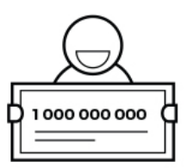
Imagine you have just won $1 000 000 000, draw or write three things that you would you do with your money.

The Lottery Ticket Pre Reading Activity (assesment FOR Learning)
Name:________________________________________
Date:________________________________
ENG2D Period_____
Imagine you have just won $1 000 000 000, draw or write three things that you would you do with your money.

