T h e M a s q u e o f t h e R e d D e a t h
By E d g a r A l l a n P o e

Translated by AmericanEnglish.state.gov and adapted by Lorraine Yates
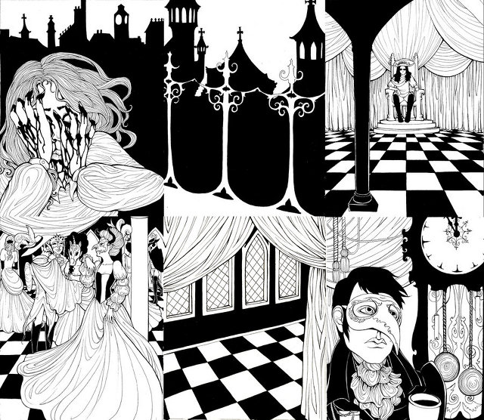

The Red Death had long been feeding on the country. No sickness had ever been so deadly — so great a killer — or so horrible to see. Blood was its mark — the redness and the horror of blood. There were sharp pains, and sudden dizziness (a feeling that the mind was rushing in circles inside the head), and then there was bleeding through the pores of the skin, instead of sweat there was blood — and then, death. The bright red spots upon the body and especially upon the face of the sick man made other men turn away from him, afraid to try to help. And the sickness lasted, from the beginning to the end, no more than half an hour.
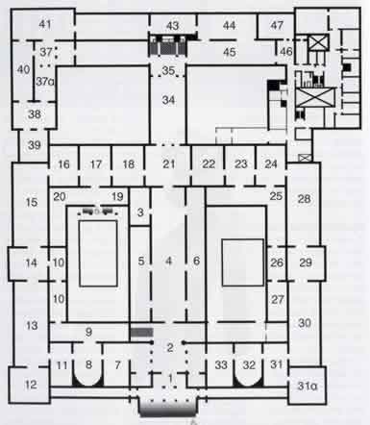
But Prince Prospero, the ruler of that land, was happy and strong and wise. When half the people of his land had died, he called to him a thousand healthy and happy friends, and with them went far away to live in one of his palaces. This was a large and beautiful stone building he had planned himself. A strong, high wall circled it. This wall had gates of iron. The gentlemen, after they had entered, brought fire to heat the iron of the gates to make them close so firmly that nobody could open them. They had decided that no one could come in or go out. Here they could forget the sickness, the Red Death. They would leave the outside world to care for itself. Prince Prospero had supplied everything they needed for pleasure. There were clowns, there were actors, there were dancers, there were musicians, there was beauty, there was wine. All these and safety were within the walls. Outside the wall walked the Red Death.
It was near the end of their fifth month there, while the Red Death raged outside, that Prince Prospero asked his thousand friends to come together for a special dancing party, a masquerade.
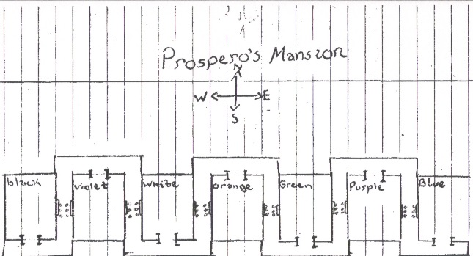
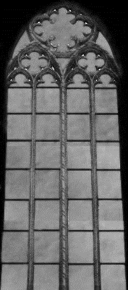
It was a scene of great richness, that masquerade. But first, let me tell you about the rooms that the masquerade was held in. There were seven rooms. In many old palaces the doors can be opened in such a way that rooms like these seven can be seen all at the same time. It is like it is one big, long room. In this palace it was different, which was not surprising since the Prince loved strange things. The rooms were arranged in such an irregular way that you could see only a bit more than one of them at a time. There was a sharp turn every twenty or thirty yards. To the right and left, in the middle of each wall, was a tall pointed window. The windows were of coloured glass, of the same colour that was used in each room. The room farthest to the East had blue cloth hangings on the walls — and its windows were blue. The second room had wall hangings of purple, and here the windows were purple.
The third was green, and so was the glass of the windows. The fourth had hangings and windows of orange — the fifth of white — the sixth of violet (light purple). But the seventh room had hangings on the walls made of a rich soft cloth which was black, black as night, and the floor, too, was covered with the same heavy black cloth. In this room the colour of the windows was not the same as the room. They were scarlet — a deep blood red colour. In not one of the rooms were there any candles or lamps.
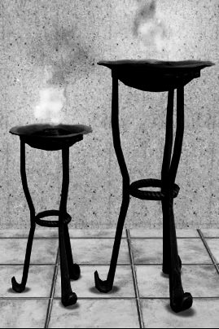
There was no light of any kind inside the rooms. But in the corridor that followed the rooms, there was a heavy tripod, supporting a fire in a brazier. The light from the fires went through the windows and gave light to the rooms. Because the fire flickered, the light inside the rooms made the objects inside look like things from a fantasy world. But the light that fell on the black hangings through the blood-coloured glass was the most fearful of them all. It produced so wild a look on the faces of those who entered that there were few of the dancers who dared to step within those dark walls.
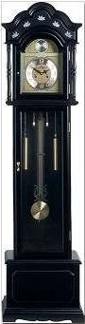
In this room, the farthest to the west, stood a huge clock of black wood against the western wall. The clock’s pendulum moved slowly back and forth making a dull and heavy sound; and when it was time to strike the hour, the bold lungs of the clock made the clock speak with a loud, clear voice, giving out a deep tone as beautiful as music, but so strange that every hour the musicians stopped to listen to the sound. Because there was no music from the musicians, the dancers had to stop, and all the happy people felt uneasy and worried while the clock struck. When the clock finished, laughter was heard again, the musicians smiled at each other, embarrassed, and promised that next time they would keep playing. But after sixty minutes (which is three thousand and six hundred seconds of time that flies by), the clock struck again and everyone stopped and felt uneasy and worried just like before.
Nevertheless, it was a happy and beautiful masquerade. The tastes of the Prince were strange. He had a sense of fashion and art for colours and effects. He had decorated the rooms in strange and wild ways, ignoring common fashion. There were some people who thought he was crazy. He friends felt that he was not. It was necessary to see him and hear him and touch him to be sure that he was not.
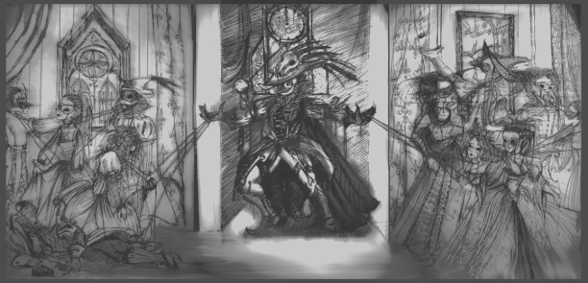
He had arranged all of the furniture and decorations in the seven rooms, and he had told the guests of the party what to wear. The costumes were strange and unnatural. There was much glitter and shining and glamour and fantasy. There were beautiful costumes with unnatural arms or legs. There were crazy fantasies that a madman might wear. There was much of the beautiful, much of the shameless, much of the bizarre, something of the terrifying, and not a little of the disgusting. In and out of the seven rooms there moved many dreams and nightmares. And these dreams were painted with the colours of the rooms, and it seemed like the music did not come from the musicians but from the movement of the dreams. And eventually the black clock that stands in the black room strikes again, and then, for a moment, everything is still and everything is silent except for the striking of the clock. The dreams are frozen where they stand, but the echoes of the clock die away – they have suffered only a moment – and a light, quite laughter floats after the echoes. Now the music gets louder, and the dreams live, moving here and there more happily than ever before, taking the many colours of the windows and the flickering fire light. But into the seventh room that lies to the west of all the rooms, the masqueraders do not dare to go, because the red light flickering through the windows, and the blackness of the wall hangings, make them afraid — and he who enters hears more deeply the striking of the great black clock. But the other rooms are crowded, and in them beat hotly the heart of life. And the dance goes on until at last the clock begins to strike twelve. And then the music stopped, and the movements of the dancers slowly stopped, and everything stopped moving, as before. But now there were twelve strokes to be sounded by the clock, and everyone had more time to think and wonder. It also happened that before the clock had finished striking, many people in the crowd became aware of a masquerader who had not been noticed before. As they talked softly to each other about him, a feeling of surprise spread through all the dancers, then a feeling of fear, of horror, and of disgust.
In such a group as this, only a very strange masquerader could have caused such a feeling. At the masquerade, anyone could do almost whatever they wanted, but this masquerader had gone beyond even what the Prince considered acceptable. Even among those who laugh at both life and death, some matters cannot be laughed at. Everyone seemed now deeply to feel that the stranger should not have been allowed to come among them dressed in such clothes. He was tall and very thin, and covered from head to foot like a dead man prepared for the grave. The mask which covered his face was so much like the face of a dead man that the no one could see the difference. And yet all this might have been acceptable, if not approved of, by the crazy-looking guests around him, but the man had gone too far by making himself look like the Red Death itself. His clothes were spotted with blood, and his mask was sprinkled with the red horror.
When Prince Prospero saw this frightening body, which moved slowly here and there among the people, he shuddered with terror, but then with rage.
“Who dares?” he demanded. “Who dares insult us with this insulting impersonation? Seize him and pull off his mask so that we may know who we must hang at sunrise from the high walls!”
Prince Prospero stood in the eastern or blue room when he spoke these words. They sounded through the seven rooms loudly and clearly because everything was still quiet. At first, as he spoke, some of the dancers started to rush toward the strange masquerader. But they stopped, afraid, and no one dared to put out a hand to touch him. The stranger started to walk toward the second room. He passed within a few feet of Prince Prospero, who stood still, surprised. And while all the dancers shrank back from the centres of the rooms to the walls, the stranger moved without being stopped, with a slow and measured step, through the blue room to the purple— through the purple to the green— through the green to the orange — through this to the white — and even to the violet before any move was made to stop him. It was then that Prince Prospero, made wild with rage and shame at his own cowardice, rushed through the six rooms. No one dared to follow him because a deadly terror had seized everyone. He held a dagger high over his head and rushed to within three or four feet of the strange masquerader, just as the stranger finally reached the black room. The unnatural figure turned and stood silent, looking at Prince Prospero. There was a loud cry — and the knife dropped shining upon the black floor, upon which immediately fell the dead Prince Prospero. Then, desperate, the dancers rushed into the black room and seized the stranger, whose tall form stood in the shadow of the black clock, but they gasped in shock and horror when they found that there was nothing behind the mask or inside the costume.
Now they admitted to themselves that it was the real Red Death amongst them. He had come like a thief in the night. One by one the dancers fell in the blood-stained rooms, and each died as he fell. And the life of the black clock ended with the last of the guests. And the fires on the tripods went out. And Darkness and Decay and the Red Death ruled forever over all.

