Vocabulary and Grammar Practice with Mr. Bean  Watch the Mr. Bean video and make a list of the following rooms he enters, the objects he interacts with, and the chores he does.  https://www.youtube.com/watch?time_continue=1&v=ekyfHNc4G4Y |  |  | 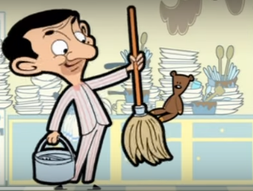
Rooms (Nouns) | Objects (Nouns) | Chores/Actions (Verbs)

Write three sentences describing Mr. Bean’s Spring cleaning using the information from the table above.

