Why We Crave Horror Movies
By Stephen King
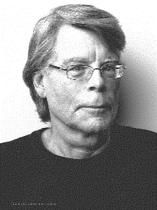
Stephen Edwin King (born September 21, 1947) is an American author of contemporary horror, supernatural fiction, suspense, science fiction, and fantasy. His books have sold more than 350 million copies, and many of them have been adapted into feature films, television movies and comic books. King has published fifty-five novels, including seven under the pen name Richard Bachman, and six non-fiction books. He has written nearly two hundred short stories, most of which have been collected in book collections. Many of his stories are set in his home state of Maine.

I think that we’re all mentally ill; those of us outside the asylums only hide it a little better – and maybe not all that much better, after all. We’ve all known people who talk to themselves, people who sometimes squinch their faces into horrible grimaces when they believe no one is watching, people who have some hysterical fear – of snakes, the dark, the tight place, the long drop . . . and, of course, those final worms and grubs that are waiting so patiently underground.

When we pay our four or five bucks and seat ourselves at tenth-row center in a theater showing a horror movie, we are daring the nightmare.

Why? Some of the reasons are simple and obvious. To show that we can, that we are not afraid, that we can ride this roller coaster. Which is not to say that a really good horror movie may not surprise a scream out of us at some point, the way we may scream when the roller coaster twists through a complete 360 or plows through a lake at the bottom of the drop. And horror movies, like roller coasters, have always been the special province of the young; by the time one turns 40 or 50, one’s appetite for double twists or 360-degree loops may be considerably depleted.  We also go to re-establish our feelings of essential normality; the horror movie is innately conservative, even reactionary. Freda Jackson as the horrible melting woman in Die, Monster, Die! confirms for us that no matter how far we may be removed from the beauty of a Robert Redford or a Diana Ross, we are still light-years from true ugliness. | Roller coaster (click here to see video)  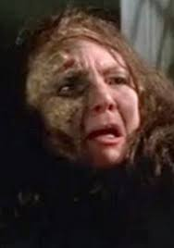  Freda Jackson (above), Diana Ross (below)
 | 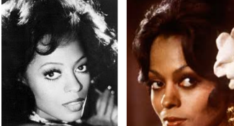

And we go to have fun.

Ah, but this is where the ground starts to slope away, isn’t it? Because this is a very peculiar sort of fun, indeed. The fun comes from seeing others menaced – sometimes killed. One critic has suggested that if pro football has become the voyeur’s version of combat, then the horror film has become the modern version of the public lynching.

It is true that the mythic “fairy-tale” horror film intends to take away the shades of grey . . . It urges us to put away our more civilized and adult penchant for analysis and to become children again, seeing things in pure blacks and whites. It may be that horror movies provide psychic relief on this level because this invitation to lapse into simplicity, irrationality and even outright madness is extended so rarely. We are told we may allow our emotions a free rein . . . or no rein at all.

If we are all insane, then sanity becomes a matter of degree. If your insanity leads you to carve up women like Jack the Ripper or the Cleveland Torso Murderer, we clap you away in the funny farm (but neither of those two amateur-night surgeons was ever caught, heh-heh-heh); if, on the other hand, your insanity leads you only to talk to yourself when you’re under stress or to pick your nose on your morning bus, then you are left alone to go about your business . . . though it is doubtful that you will ever be invited to the best parties.

The potential lyncher is in almost all of us (excluding saints, past and present; but then, most saints have been crazy in their own ways), and every now and then, he has to be let loose to scream and roll around in the grass. Our emotions and our fears form their own body, and we recognize that it demands its own exercise to maintain proper muscle tone. Certain of these emotional muscles are accepted – even exalted – in civilized society; they are, of course, the emotions that tend to maintain the status quo of civilization itself. Love, friendship, loyalty, kindness -- these are all the emotions that we applaud, emotions that have been immortalized in the couplets of Hallmark cards and in the verses (I don’t dare call it poetry) of Leonard Nimoy. | 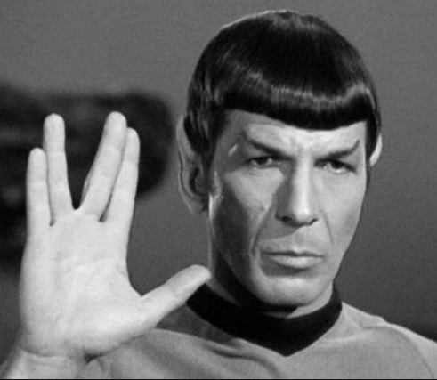  Leonard Nimoy
When we exhibit these emotions, society showers us with positive reinforcement; we learn this even before we get out of diapers. When, as children, we hug our rotten little puke of a sister and give her a kiss, all the aunts and uncles smile and twit and cry, “Isn’t he the sweetest little thing?” Such coveted treats as chocolate-covered graham crackers often follow. But if we deliberately slam the rotten little puke of a sister’s fingers in the door, sanctions follow – angry remonstrance from parents, aunts and uncles; instead of a chocolate-covered graham cracker, a spanking.

But anticivilization emotions don’t go away, and they demand periodic exercise. We have such “sick” jokes as, “What’s the difference between a truckload of bowling balls and a truckload of dead babies?” (You can’t unload a truckload of bowling balls with a pitchfork . . . a joke, by the way, that I heard originally from a ten-year-old.) Such a joke may surprise a laugh or a grin out of us even as we recoil, a possibility that confirms the thesis: If we share a brotherhood of man, then we also share an insanity of man. None of which is intended as a defense of either the sick joke or insanity but merely as an explanation of why the best horror films, like the best fairy tales, manage to be reactionary, anarchistic, and revolutionary all at the same time.

The mythic horror movie, like the sick joke, has a dirty job to do. It deliberately appeals to all that is worst in us. It is morbidity unchained, our most base instincts let free, our nastiest fantasies realized . . . and it all happens, fittingly enough, in the dark. For those reasons, good liberals often shy away from horror films. For myself, I like to see the most aggressive of them – Dawn of the Dead, for instance – as lifting a trap door in the civilized forebrain and throwing a basket of raw meat to the hungry alligators swimming around in that subterranean river beneath.  Why bother? Because it keeps them from getting out, man. It keeps them down there and me up here. It was Lennon and McCartney who said that all you need is love, and I would agree with that.  As long as you keep the gators fed. | 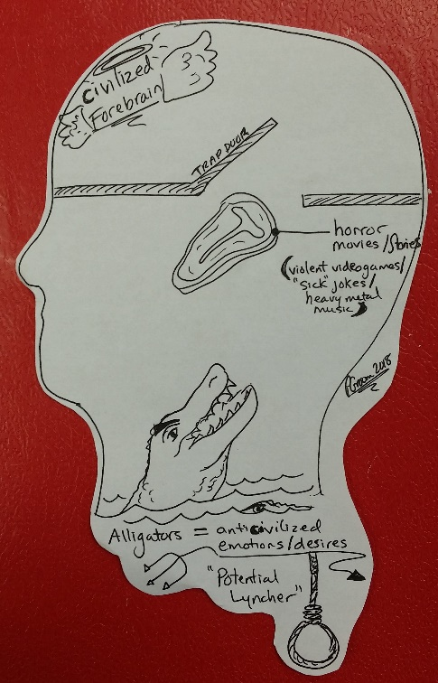
“Why We Crave Horror Movies” Discussion Questions

Please write down your answers individually, using complete sentences. Once you are finished, please discuss your answers in your group.

- According to King, what causes people to crave horror movies? What other reasons can you add to King’s list?
- King says people crave horror movies because we are all mentally ill- some of us just hide it better!
- To show we’re not afraid
- Re-establish essential normality
- To have fun

- Identify the analogy King uses in the third paragraph, and explain how it works.
He uses the analogy of the roller coaster to help us identify with this idea. Not everyone who reads this essay likes horror movies, BUT they might like roller coasters (MAKES IT EASIER TO UNDERSTAND).

- What does King mean when he says, “The horror movie is innately conservative, even reactionary”?
-In horror movies, everything happens so quickly that the characters must react quickly for survival.
-By contrast our lives seem much more calm and we feel like we are in better control of our lives.

- What emotions does society applaud? Why? Which ones does King label “anticivilization” emotions?
Good emotions (applauded/ civilized)  - Love  - Happiness  - Excitement  - Friendship  - Kindness  - loyalty  These are considered good because they help society function (work). | Negative emotions (anti-civilized)  - hate  - sadness (depression)  - indifference or down-hearted  - isolation (hermit/loner)  - Violence  - Betrayal  These are considered bad because they weaken/destroy our society.

- In what ways is a horror like a sick joke? What is the “dirty job” or effect that the two have in common?
It deliberately appeals to all that is worst in us. It is morbidity unchained, our most base instincts let free, our nastiest fantasies realized. ( It allows us the freedom to act “bad” without the negative consequences)

- King starts his essay with the attention-grabbing sentence, “I think that we’re all mentally ill.” How does he develop this idea of insanity in his essay?

- See Highlighted material in essay

- What does King mean when he says, “The potential lyncher is in almost all of us”?
It means that we all like to watch people suffer (physically or mentally).

- How does King’s last line relate to the theme of mental illness?
The last line, “As long as we keep the gators fed,” relates to the theme of mental illness by saying we have evil hungry alligators in our head. This is just a metaphor but King treats these metaphorical alligators as REAL creatures. This makes King seem crazy.

- What is King’s tone in this essay? Point to particular words or sentences that lead you to this conclusion.
Informal
- uses colloquial/casual language (little puke of a sister)
- uses lots of jokes and asides
Playful
- references roller coasters
- jokes
- “heheheh”
Mysterious
Crazy
Humerous

